

**Database Systems Project Part II**

**Logical Schema Optimization and Unstructured Data Collection**

**Course Title:** Database Systems **Course Number:** CSCI-GA.2433-001

**Instructor:** Jean-Claude Franchitti

**Team Members:**

|  |  |  |
| --- | --- | --- |
| **Name:** Dedeepya Guntaka  **Net ID:** dg4489  **NYU ID:** N18304471 | **Name:** Shivam Dheer  **Net ID:** sd6080 **NYU ID:** N18103074 | **Name:** Varun Putta  **Net ID:** vsp7221  **NYU ID:** N10489122 |

**Database Systems Project Part II - Logical Schema Optimization and Unstructured Data Collection**

***Project Objective:*** *Designing an Enterprise Data Architecture for Integrated, Scalable, and Governed Data Management to Predict and Reduce Employee Attrition.*

**Problem Statement**

Employee attrition is a significant challenge, affecting productivity, morale, and costs. This project aims to design a comprehensive EDA that enables efficient data management across traditional storage systems and supports predictive analytics to identify high-risk employees likely to leave. The company can tailor interventions that improve employee retention, optimise workplace conditions, and mitigate attrition-related costs by leveraging a structured data environment.

**Ongoing Project Background**

The first phase of the project focused on designing a robust **Enterprise Data Architecture (EDA)** that facilitates employee attrition prediction and enables effective data governance and integration. This stage laid the foundation for a scalable and reliable framework by emphasizing a centralized data model, data quality standards, and system architecture for real-time data integration, historical trend analysis, and predictive modelling.

Through the creation of an **Entity-Relationship Diagram (ERD)**, the team established key entities such as Employee, Job Satisfaction, Compensation, Performance, and Work Patterns, capturing a holistic view of employee data across various dimensions. In addition, the project team outlined a conceptual model with defined relationships between entities and implemented best practices for data governance to ensure high data accuracy, security, and compliance.

In the second phase of the project, the focus shifts toward operationalizing and expanding the EDA by integrating **real-world datasets** (e.g., HR_Employee_Attrition.csv) and implementing the predictive and analytical capabilities outlined in Part 1. The goal is to translate the conceptual framework into actionable deliverables, enabling the company to predict attrition and recommend personalized interventions in a dynamic and scalable environment.

*Key priorities for this phase include:*

1. **Data Integration and Preparation**
   * Importing and cleansing the data from the provided HR_Employee_Attrition.csv dataset, ensuring it aligns with the conceptual data model.
   * Implementing **ETL processes** to transform raw data into a standardized format, ready for analysis and reporting.
2. **Building Predictive Models**
   * Developing machine learning models to analyze critical factors such as job satisfaction, compensation, performance ratings, and work-life balance to predict attrition risk.
   * Training and validating the models using historical data to ensure high accuracy and reliability.
3. **Interactive Analytics and Reporting**
   * Designing **dashboard visualizations** using tools like Tableau or Power BI to provide real-time insights into employee attrition trends, high-risk groups, and actionable recommendations for managers.
   * Monitoring metrics such as retention rates, satisfaction scores, and department-level turnover statistics.
4. **Operationalization of EDA Components**
   * Deploying the **Operational Data Store (ODS)** to support real-time updates and seamless integration with HR systems.
   * Establishing **Data Marts** for Compensation, Performance, and Work Patterns, enabling focused and efficient analytics.
5. **Feedback Loop for Continuous Improvement**
   * Iteratively refining the models and reports based on managerial feedback, ensuring alignment with business needs and practical utility.
   * Incorporating additional attributes or external datasets as needed to enhance predictive accuracy and insights.

This phase emphasizes the application of advanced analytics within the EDA framework to deliver actionable insights, reduce attrition-related costs, and improve employee satisfaction. It bridges the gap between theoretical design and practical implementation, aligning data-driven strategies with organizational goals.

**Mapping of Entities to the Relational Model**

To implement the conceptual model designed in the first phase of the project, each identified entity is mapped into a relational schema. The mapping ensures that the data is normalized, maintains referential integrity, and supports efficient querying and reporting. Below is the mapping of entities from the conceptual model into their corresponding relational tables with primary keys (PK) and foreign keys (FK):

**1. Employee Table**

**Purpose:** Captures core employee details, including demographic and work-life balance information.

**Attributes:**

* EmployeeNumber (PK)
* Over18
* Gender
* MaritalStatus
* DistanceFromHome
* StandardHours
* WorkLifeBalance

**2. PersonalInfo Table**

**Purpose:** Stores personal information related to employees.

**Attributes:**

* EmployeeNumber (PK, FK)
* Age
* EducationField
* Education
* RelationshipSatisfaction

**Relationships:** One-to-One relationship with **Employee** (EmployeeNumber as FK).

**3. Manager Table**

**Purpose:** Represents details of employees in managerial roles and their scope of responsibility.

**Attributes:**

* ManagerID (PK)
* EmployeeNumber (FK)
* ManagementLevel
* TeamSize
* ResponsibilityArea

**Relationships:** One-to-Many relationship with **Employee** (one manager supervises many employees).

**4. Compensation Table**

**Purpose:** Stores financial details related to employee earnings and benefits.

**Attributes:**

* EmployeeNumber (PK, FK)
* DailyRate
* HourlyRate
* MonthlyRate
* MonthlyIncome
* StockOptionLevel
* Benefits
* Bonus

**Relationships:** One-to-One relationship with **Employee** (EmployeeNumber as FK).

**5. EmploymentHistory Table**

**Purpose:** Tracks the employment history of each employee, including previous companies and tenure.

**Attributes:**

* HistoryID (PK)
* EmployeeNumber (FK)
* NumCompaniesWorked
* TotalWorkingYears
* PreviousCompany
* StartDate
* EndDate

**Relationships:** One-to-Many relationship with **Employee** (EmployeeNumber as FK).

**6. JobDetails Table**

**Purpose:** Provides detailed job-related information for employees.

**Attributes:**

* EmployeeNumber (PK, FK)
* JobRole
* JobLevel
* JobInvolvement
* JobSatisfaction
* EnvironmentSatisfaction
* BusinessTravel
* OverTime
* YearsInCurrentRole
* YearsSinceLastPromotion
* YearsAtCompany
* YearsWithCurrManager

**Relationships:** One-to-One relationship with **Employee** (EmployeeNumber as FK).

**7. Performance Table**

**Purpose:** Tracks employee performance metrics and related information.

**Attributes:**

* PerformanceID (PK)
* EmployeeNumber (FK)
* PerformanceRating
* PercentSalaryHike
* ReviewDate
* Feedback
* Goals

**Relationships:** One-to-Many relationship with **Employee** (EmployeeNumber as FK).

**8. Department Table**

**Purpose:** Represents departments within the organization and their attributes.

**Attributes:**

* DepartmentID (PK)
* DepartmentName
* EmployeeCount
* Location
* Budget

**Relationships:**

* Many-to-One relationship with **Employee** (DepartmentID as FK in **Employee**).
* One-to-Many relationship with **Project** (DepartmentID as FK in **Project**).

**9. Project Table**

**Purpose:** Tracks details of projects managed by departments.

**Attributes:**

* ProjectID (PK)
* DepartmentID (FK)
* ProjectName
* StartDate
* EndDate
* Status
* Priority

**Relationships:** One-to-Many relationship with **Department** (DepartmentID as FK).

**10. Training Table**

**Purpose:** Stores data related to employee training programs and certifications.

**Attributes:**

* TrainingID (PK)
* EmployeeNumber (FK)
* TrainingName
* TrainingTimesLastYear
* CompletionDate
* Status
* Certification

**Relationships:** One-to-Many relationship with **Employee** (EmployeeNumber as FK).

**Key Considerations in Mapping**

1. **Primary Keys (PK):**

Each table includes a unique primary key to ensure no duplicate records and to uniquely identify each entry.

1. **Foreign Keys (FK):**

Foreign keys are used to establish relationships between entities and ensure referential integrity.

1. **Normalization:**

The schema is normalized to avoid redundancy and ensure consistency, aligning with the goals of a scalable and efficient database.

1. **Scalability:**

The relational model is designed to allow the addition of new attributes or entities with minimal structural changes.

1. **Query Efficiency:**

Relationships and keys are structured to support quick retrieval of data for predictive analytics, reporting, and dashboard visualization.

This relational schema provides a clear, structured representation of the entities, making the database implementation intuitive and efficient while maintaining alignment with the overall project goals.

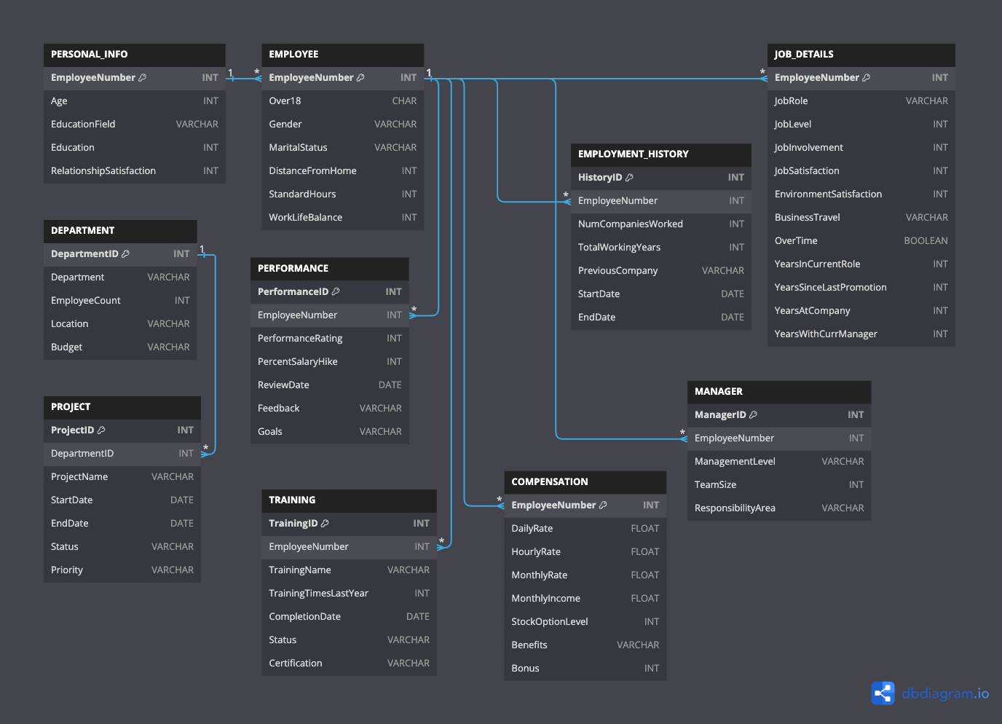**Entity to Relational Mapping**

**EDA Logical Schema Optimization**

The logical schema defines the structure of the database in a way that balances efficient data retrieval, storage, and maintenance. Optimization involves normalizing the schema to reduce redundancy, ensure data integrity, and improve performance. For this schema, normalization is applied systematically across three levels (1NF, 2NF, and 3NF) to ensure an efficient and robust database design.

**First Normal Form (1NF)**

1NF requires that:

1. The values in each column of a table are atomic (indivisible).
2. Each row is unique and identified by a primary key.
3. The table does not contain any repeating groups or arrays.

**Applying 1NF:** All tables in the provided schema comply with 1NF as:

* Each column contains atomic values (e.g., Age, EducationField).
* Primary keys (EmployeeNumber, HistoryID, etc.) ensure unique rows.
* No repeating groups exist in any table.

For example, in the EMPLOYMENT_HISTORY table, each record corresponds to a unique employment history entry for an employee, without repeating groups or multi-valued attributes.

**Second Normal Form (2NF)**

2NF requires that:

1. The table is in 1NF.
2. All non-prime attributes are fully functionally dependent on the primary key (no partial dependency).

**Applying 2NF:** In the given schema, partial dependencies are avoided by ensuring:

* Attributes directly dependent on the primary key are placed in their respective tables.
* For example, in the PERFORMANCE table, attributes like PerformanceRating, PercentSalaryHike, and ReviewDate depend fully on PerformanceID (the primary key).

If any partial dependencies existed (e.g., if Department details were stored in the EMPLOYEE table), they were resolved by moving the attributes into separate tables like DEPARTMENT.

**Third Normal Form (3NF)**

3NF requires that:

1. The table is in 2NF.
2. All attributes are functionally dependent only on the primary key and not on any other non-prime attributes (no transitive dependency).

**Applying 3NF:**

* Transitive dependencies have been resolved by breaking the schema into additional tables where necessary.
* For example:
  + In the COMPENSATION table, attributes like DailyRate, MonthlyRate, and StockOptionLevel depend directly on EmployeeNumber without intermediary dependencies.
  + The separation of MANAGER and DEPARTMENT ensures that Manager information is not redundantly stored in the DEPARTMENT table, eliminating potential transitive dependencies.

**Normalization Code**

Below is the code for verifying and applying normalization during schema creation:

**-- Verifying 1NF: Ensuring atomic columns and unique rows**

**SELECT * FROM EMPLOYEE;**

**-- Applying 2NF: Resolving partial dependencies**

**-- Example: Moving department details out of EMPLOYEE table**

**CREATE TABLE DEPARTMENT (**

**DepartmentID INT PRIMARY KEY AUTO_INCREMENT,**

**DepartmentName VARCHAR(50),**

**Location VARCHAR(100)**

**);**

**ALTER TABLE EMPLOYEE**

**DROP COLUMN Department,**

**ADD COLUMN DepartmentID INT,**

**ADD FOREIGN KEY (DepartmentID) REFERENCES DEPARTMENT(DepartmentID);**

**-- Applying 3NF: Resolving transitive dependencies**

**-- Example: Moving compensation details into a separate table**

**CREATE TABLE COMPENSATION (**

**EmployeeNumber INT PRIMARY KEY,**

**DailyRate FLOAT,**

**HourlyRate FLOAT,**

**MonthlyIncome FLOAT,**

**FOREIGN KEY (EmployeeNumber) REFERENCES EMPLOYEE(EmployeeNumber)**

**);**

**-- Ensuring no transitive dependency in PERFORMANCE**

**CREATE TABLE PERFORMANCE (**

**PerformanceID INT PRIMARY KEY AUTO_INCREMENT,**

**EmployeeNumber INT,**

**PerformanceRating INT,**

**ReviewDate DATE,**

**FOREIGN KEY (EmployeeNumber) REFERENCES EMPLOYEE(EmployeeNumber)**

**);**

This normalization ensures that the schema is optimized for efficient storage, integrity, and scalability, supporting complex queries and reports without redundancy or inconsistency.

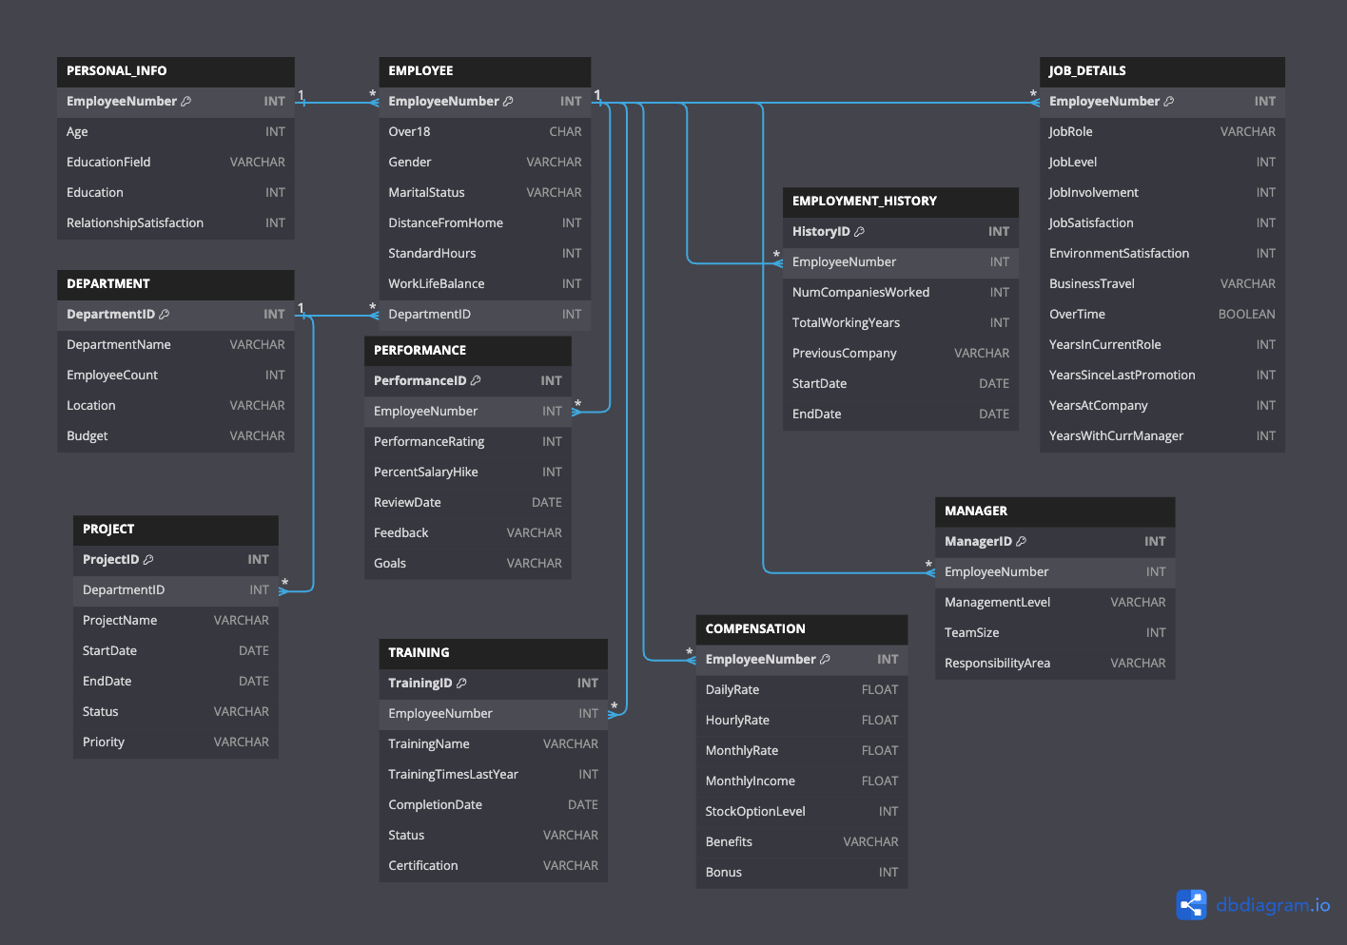

**Key Normalization Steps Implemented:**

1. **First Normal Form (1NF):**
   * All attributes contain atomic values (e.g., no repeating groups or multi-valued attributes).
   * Each column contains a single value for every row.
2. **Second Normal Form (2NF):**
   * Removed partial dependencies by ensuring all non-key attributes are fully dependent on the primary key.
   * For instance, Department details were moved to the DEPARTMENT table.
3. **Third Normal Form (3NF):**
   * Eliminated transitive dependencies by separating data into related tables (e.g., separating DEPARTMENT and MANAGER from EMPLOYEE).

**Unstructured Data Collection**

Unstructured data refers to data that does not conform to a predefined schema or format. It often includes qualitative or semi-structured information, such as text, images, videos, or logs, and is typically stored in flexible formats like NoSQL databases, JSON, or key-value pairs.

**Collection Process:**

Unstructured data for this scenario focuses on collecting high-level information about department attrition rates over time. This can include qualitative insights such as employee exit reasons or turnover patterns across departments. Some methods of collecting unstructured data include:

1. **Employee Surveys and Feedback:** Capturing exit interviews or feedback through text fields.
2. **Departmental Reports:** Gathering free-text data from reports on attrition causes.
3. **System Logs:** Analyzing logs related to employee management systems for patterns.
4. **Social Media and Communication Platforms:** Mining employee sentiments or reviews posted on internal channels or public forums.

**Example of Unstructured Data Storage:**

For instance, in the DEPARTMENT_ATTRITION table:

* Attributes like TurnoverRate (quantified from analysis) and Date offer structured insights derived from unstructured reports.
* Qualitative data (like reasons for turnover or sentiments) can be stored in external NoSQL systems or text files and processed later.

**Structured Data Collection**

Structured data refers to highly organized data that adheres to a fixed schema, typically stored in relational databases with tables, rows, and columns. It is easily searchable and analyzable using SQL and other tools.

**Collection Process:**

Structured data in this context is systematically collected through predefined input mechanisms in the Employee Management system. The data represents detailed employee and departmental information, including their job roles, performance, compensation, and training history.

Methods of collection include:

1. **HR Systems:** Employee details are gathered during onboarding and routine updates.
2. **Automated Data Entry:** Systems such as attendance or performance tracking tools provide structured inputs.
3. **Departmental Management:** Department-related structured data like budgets and employee counts are captured in database tables.
4. **Manual Input:** Supervisors or HR personnel can manually enter or update employee and departmental data.

**Example of Structured Data Storage:**

The tables uploaded above exemplify structured data storage. Each table is clearly defined, ensuring consistency and reliability. For example:

* EMPLOYEE table collects attributes such as EmployeeNumber, Gender, MaritalStatus, and DistanceFromHome.
* PERFORMANCE table captures performance metrics like PerformanceRating, PercentSalaryHike, and ReviewDate.

**Comparison with Unstructured Data:**

* Structured data focuses on precision and predefined relationships, while unstructured data captures broader, less structured aspects of employee attrition.
* Together, these data types provide a holistic view of organizational trends, with structured data supporting analytics and unstructured data offering richer context.

**Dataset Descriptions**

1. **Main Dataset (Structured) - HR_Employee_Analytics.csv**
   * Description: This dataset contains structured employee data including demographic information, job details, performance metrics, and satisfaction scores.
   * Key Columns:
     + EmployeeNumber: Unique identifier for each employee.
     + Department, JobRole, EducationField: Categorical information about employees' work and education background.
     + Attrition, PerformanceRating: Indicators of employee retention and performance.
2. **Unstructured Communication Logs - Unstructured_Communication_Logs.csv**
   * Description: Logs of employee communications such as emails, chats, and meetings. It provides insight into collaboration patterns and topics discussed.
   * Key Columns:
     + EmployeeID: Identifier linking to the main dataset.
     + Timestamp, CommunicationType, Content: Details of communication.
     + KeywordsExtracted, TopicCategory: Extracted insights from communication.
3. **Unstructured Employee Feedback - Unstructured_Employee_Feedback.csv**
   * Description: Survey responses and feedback from employees about work experiences, satisfaction, and sentiments.
   * Key Columns:
     + EmployeeID: Identifier linking to the main dataset.
     + SurveyDate, Feedback: Free-text responses with survey dates.
     + SatisfactionScore, SentimentAnalysis: Qualitative and quantitative analysis of employee satisfaction.

**Dataset Screenshots**

**PRIMARY DATASET**

**HR_Employee_Analytics.csv (Main Dataset)**

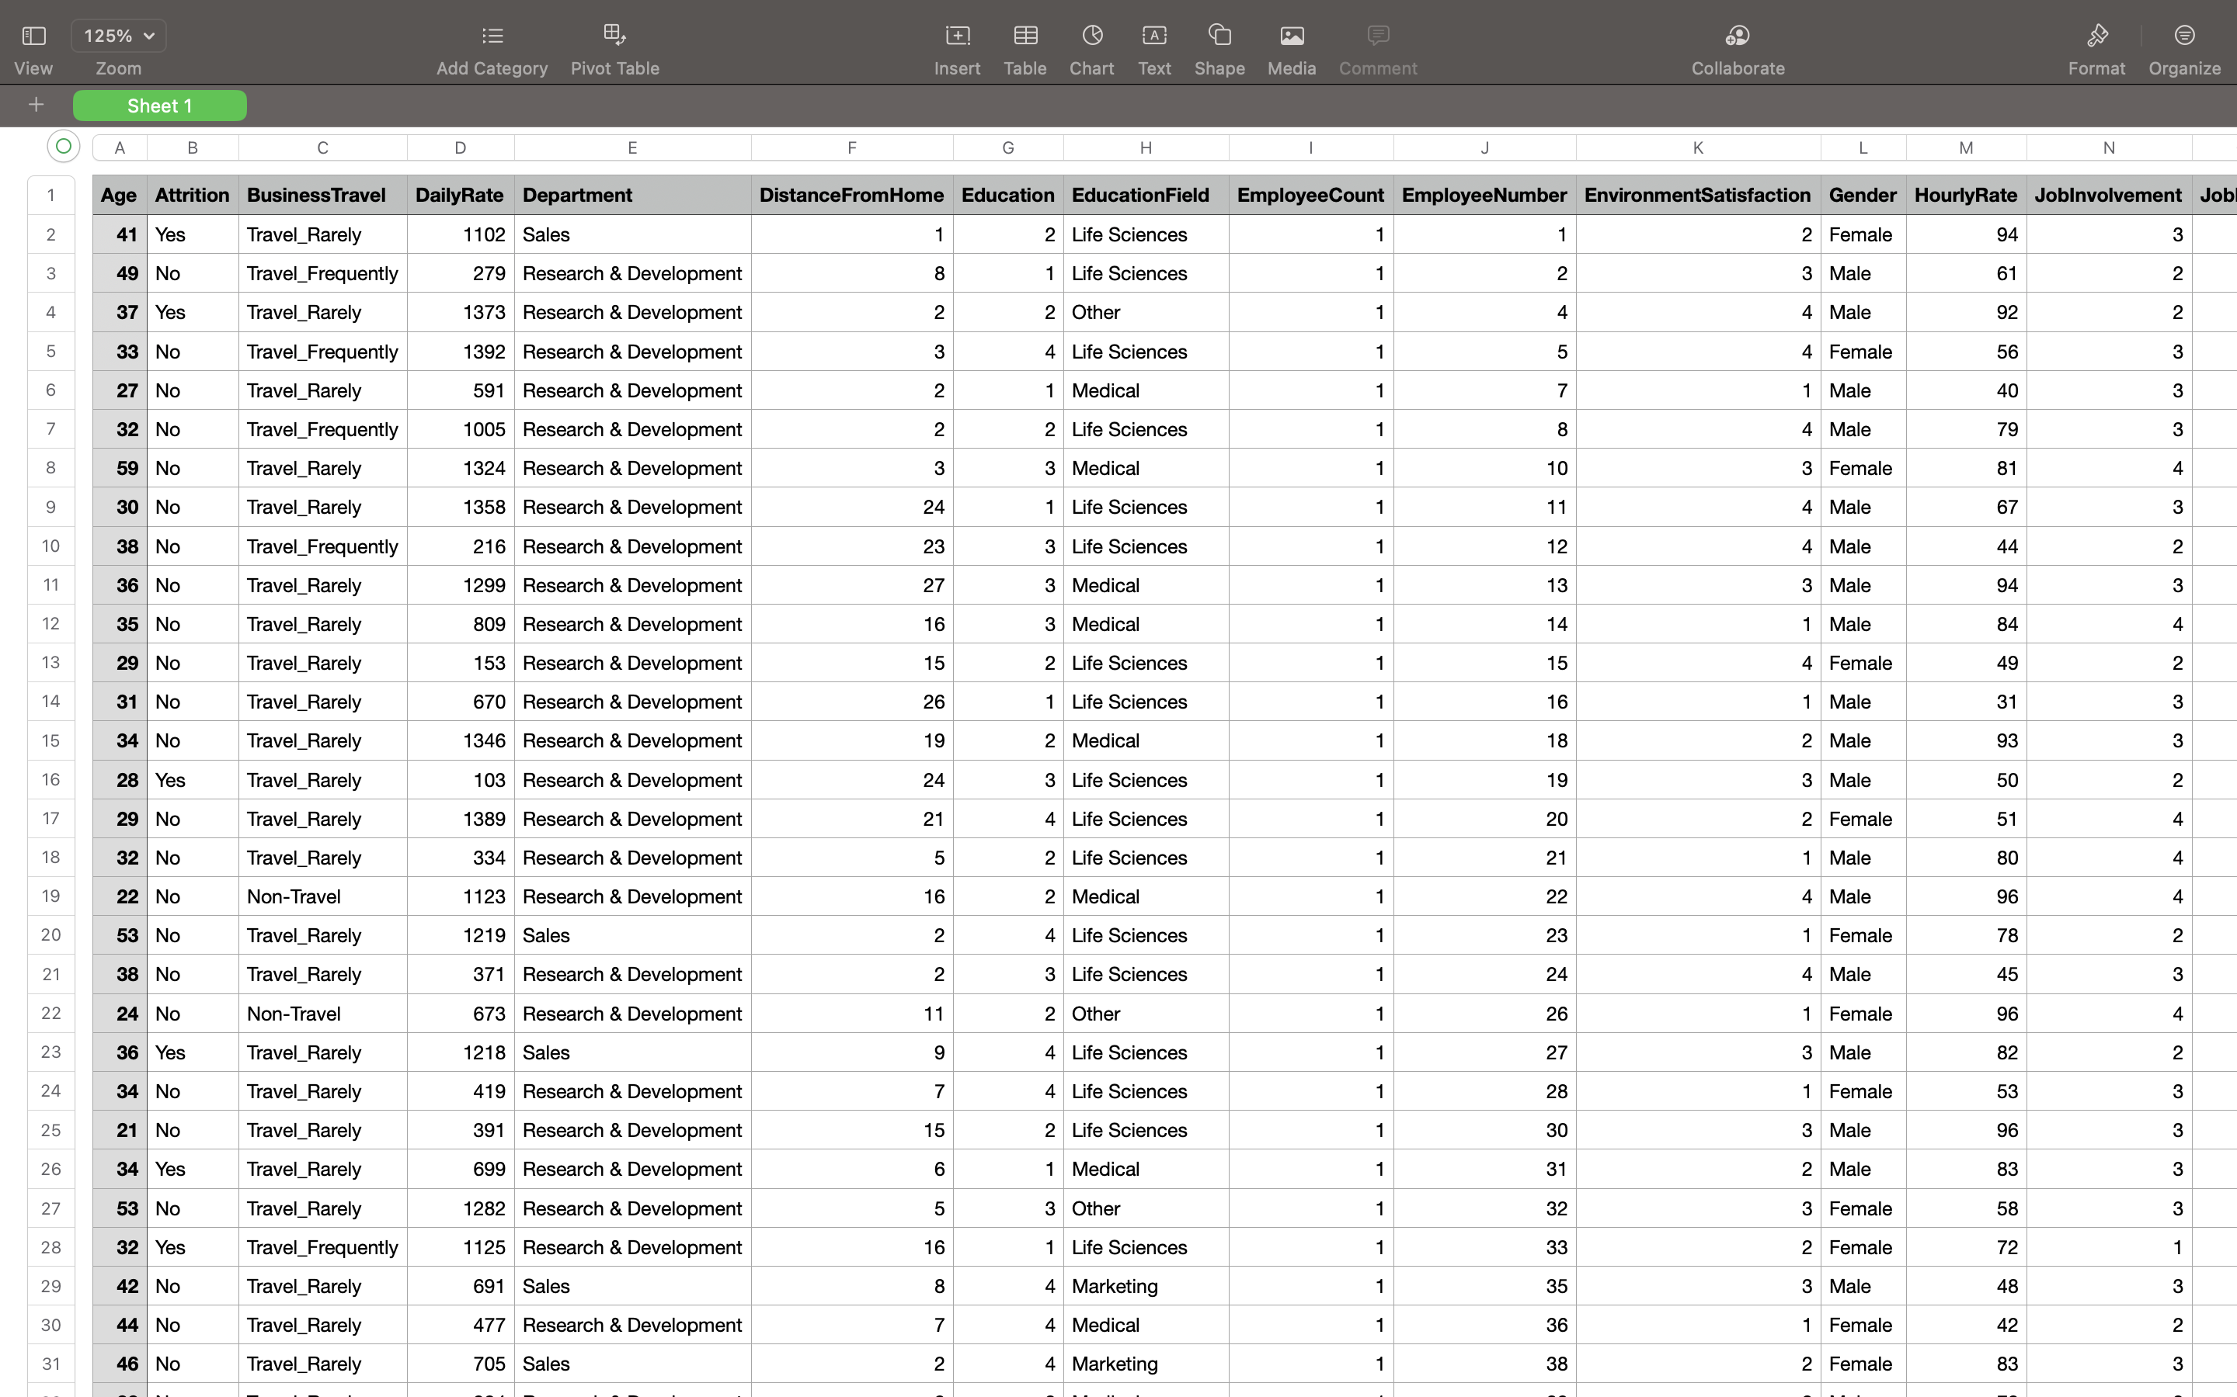

**ADDITIONAL DATASETS**

**Unstructured_Communication_Logs.csv (Unstructured Dataset 1)**

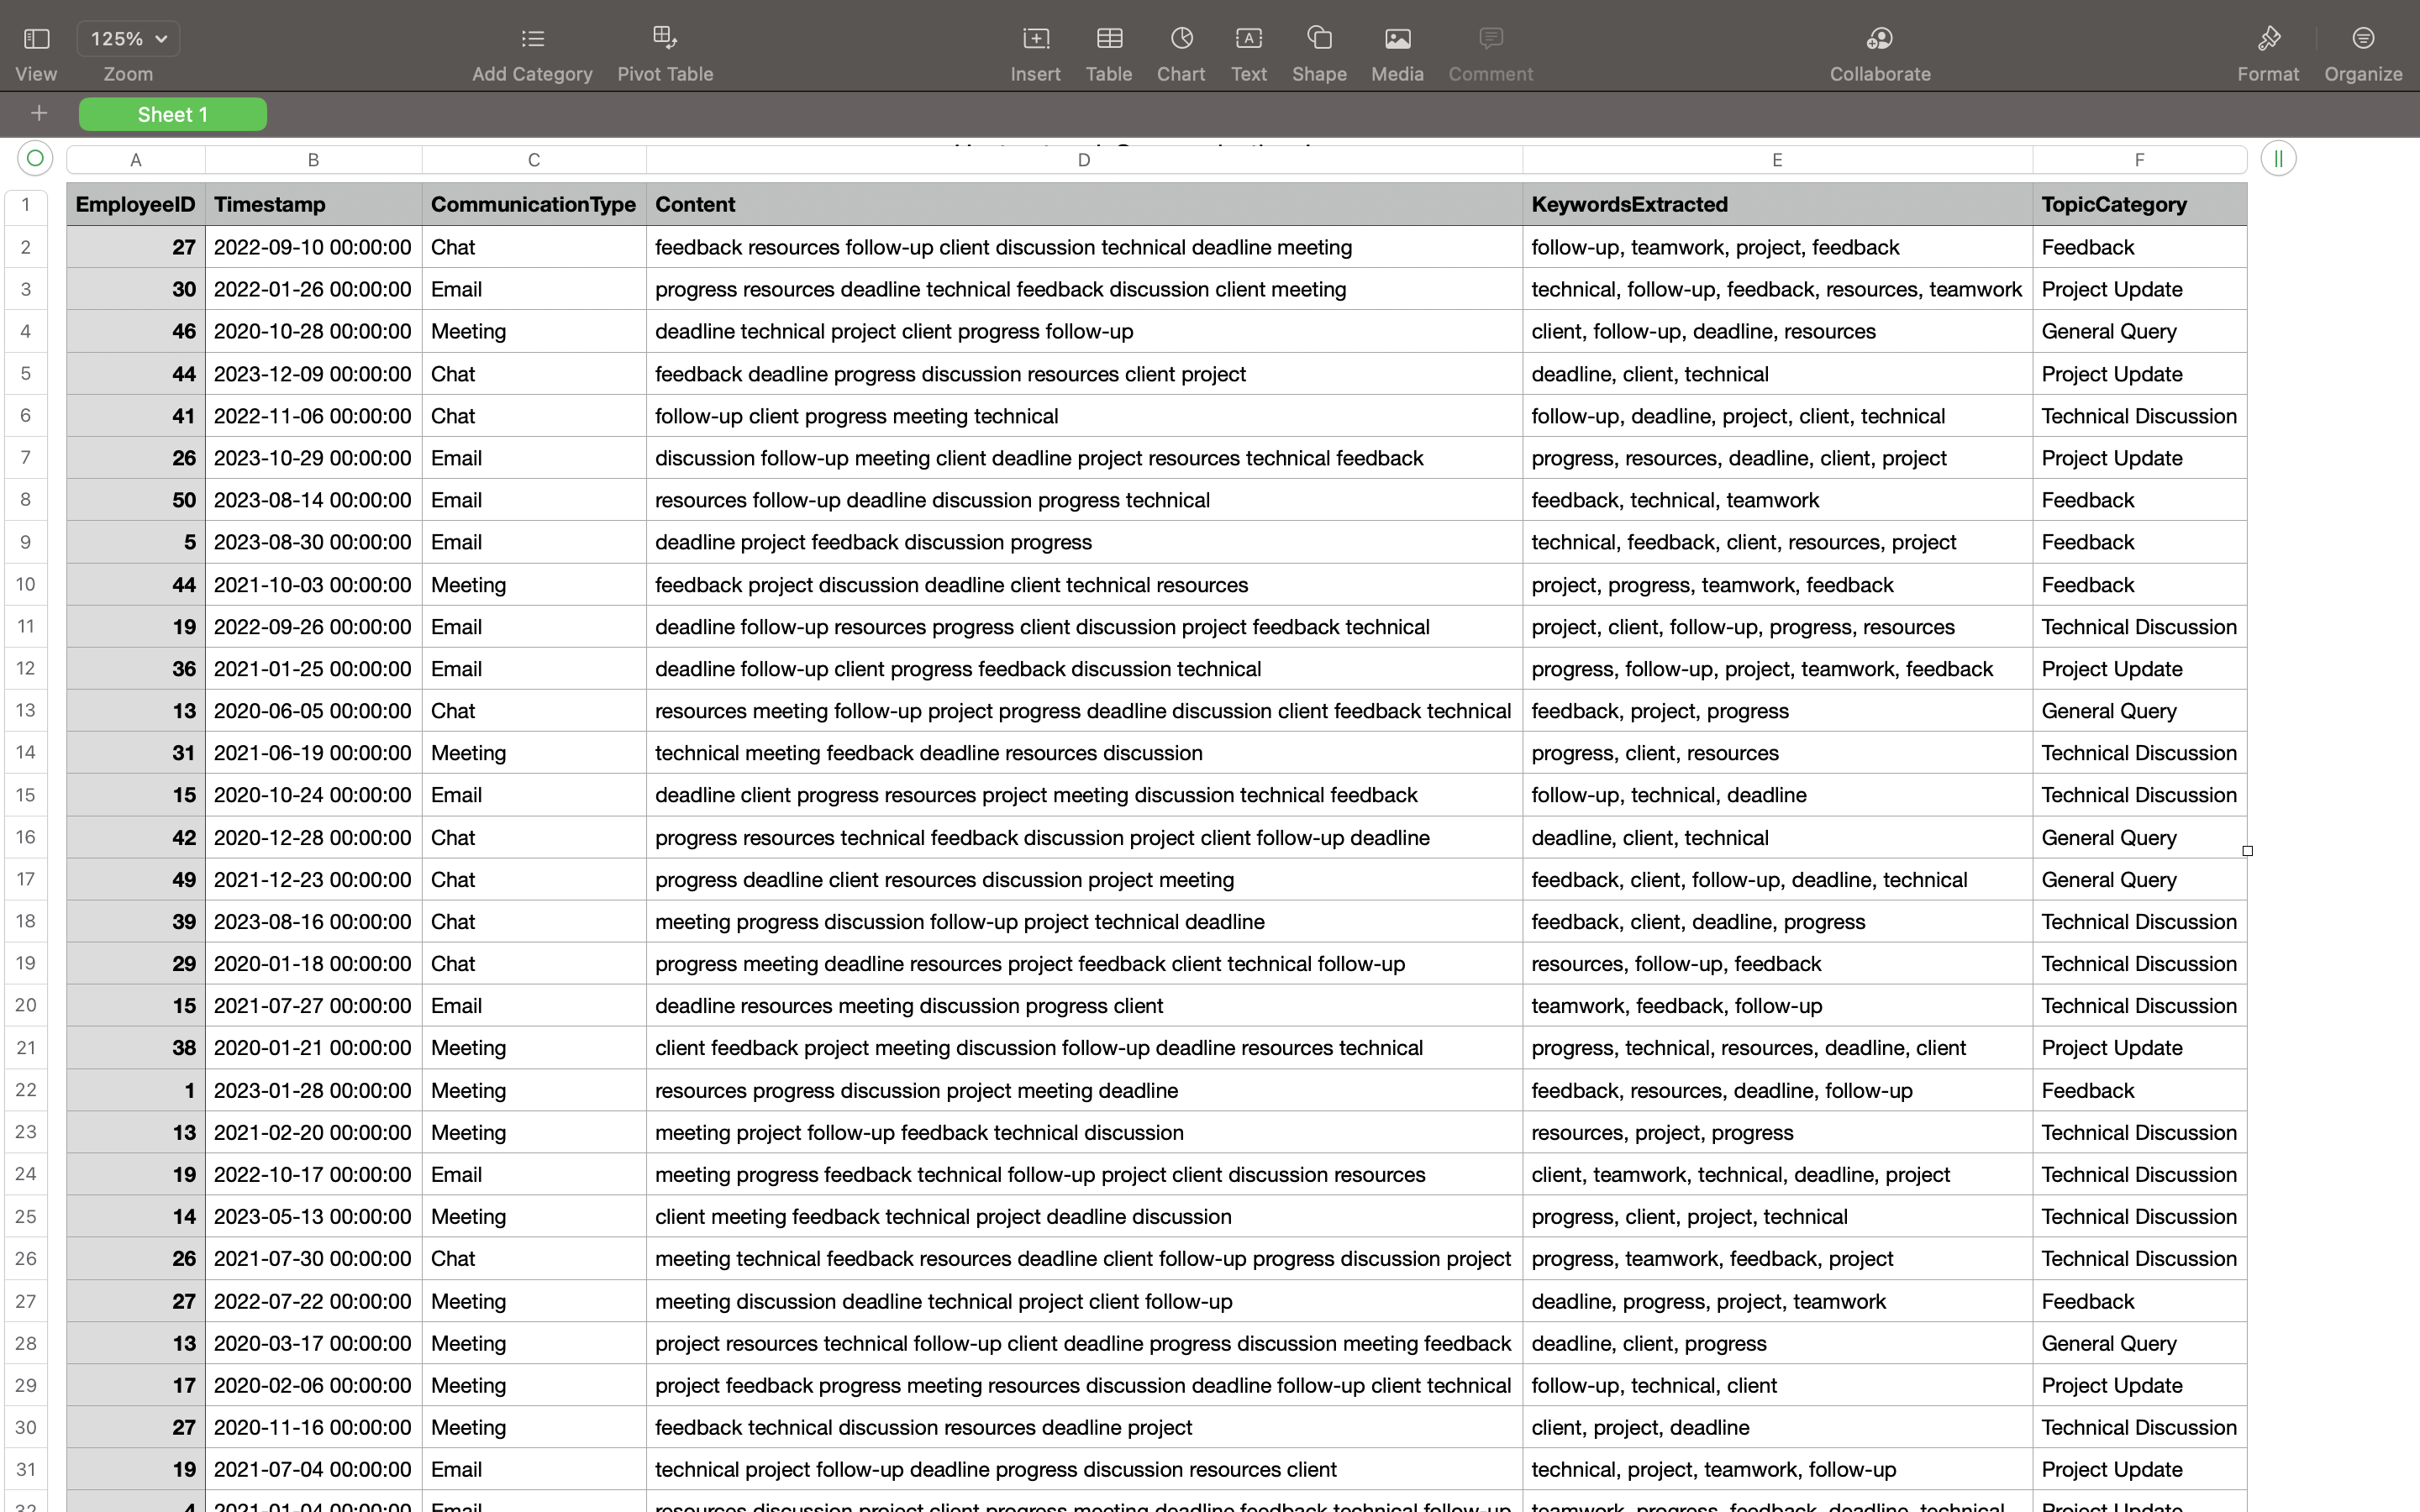

**Unstructured_Employee_Feedback.csv**

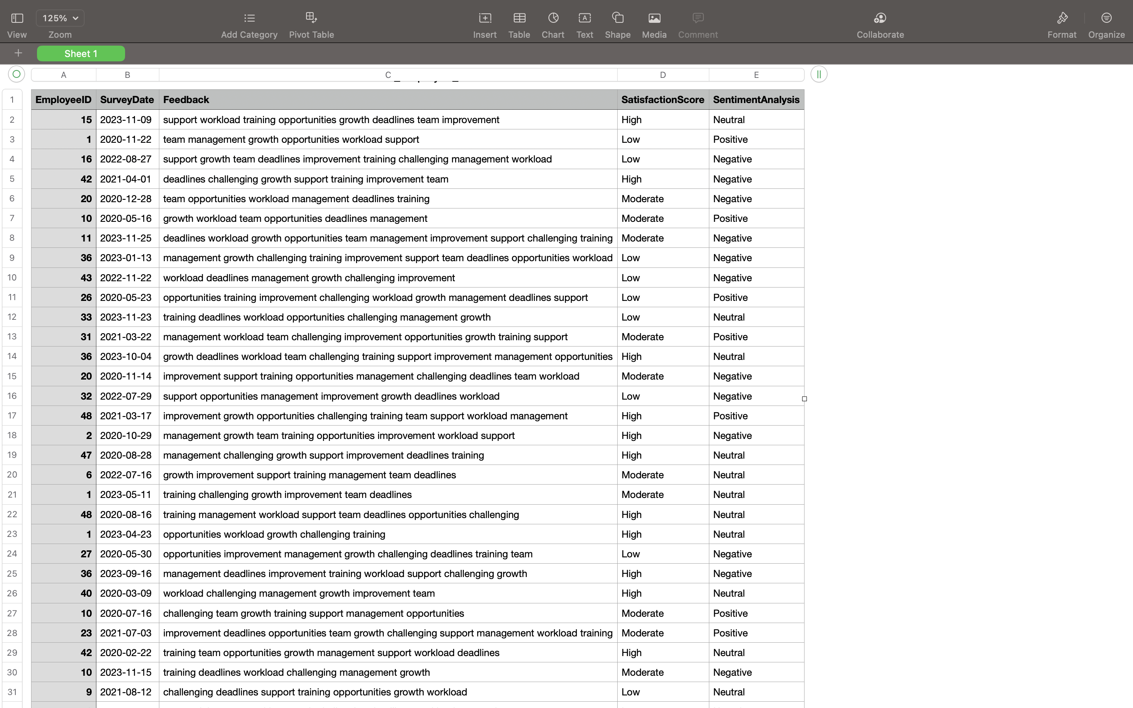

**SQL Queries to Create Tables**

**Main Dataset Table**

**CREATE TABLE HR_Employee_Analytics (**

**EmployeeNumber INT PRIMARY KEY,**

**Age INT,**

**Attrition VARCHAR(10),**

**BusinessTravel VARCHAR(50),**

**DailyRate INT,**

**Department VARCHAR(100),**

**DistanceFromHome INT,**

**Education INT,**

**EducationField VARCHAR(100),**

**EmployeeCount INT,**

**EnvironmentSatisfaction INT,**

**Gender VARCHAR(10),**

**HourlyRate INT,**

**JobInvolvement INT,**

**JobLevel INT,**

**JobRole VARCHAR(100),**

**JobSatisfaction INT,**

**MaritalStatus VARCHAR(50),**

**MonthlyIncome INT,**

**MonthlyRate INT,**

**NumCompaniesWorked INT,**

**Over18 CHAR(1),**

**OverTime VARCHAR(10),**

**PercentSalaryHike INT,**

**PerformanceRating INT,**

**RelationshipSatisfaction INT,**

**StandardHours INT,**

**StockOptionLevel INT,**

**TotalWorkingYears INT,**

**TrainingTimesLastYear INT,**

**WorkLifeBalance INT,**

**YearsAtCompany INT,**

**YearsInCurrentRole INT,**

**YearsSinceLastPromotion INT,**

**YearsWithCurrManager INT**

**);**

**Unstructured Communication Logs Table**

**CREATE TABLE Unstructured_Communication_Logs (**

**EmployeeID INT,**

**Timestamp DATETIME,**

**CommunicationType VARCHAR(50),**

**Content TEXT,**

**KeywordsExtracted TEXT,**

**TopicCategory VARCHAR(100),**

**FOREIGN KEY (EmployeeID) REFERENCES HR_Employee_Analytics(EmployeeNumber)**

**);**

**Unstructured Employee Feedback Table**

**CREATE TABLE Unstructured_Employee_Feedback (**

**EmployeeID INT,**

**SurveyDate DATE,**

**Feedback TEXT,**

**SatisfactionScore VARCHAR(20),**

**SentimentAnalysis VARCHAR(20),**

**FOREIGN KEY (EmployeeID) REFERENCES HR_Employee_Analytics(EmployeeNumber)**

**);**

These SQL queries establish relational tables that maintain a link between the structured and unstructured data through the EmployeeID/EmployeeNumber column, supporting a hybrid data model for analysis.

**ER Diagram**

This diagram divides the **main dataset** into multiple relational tables to normalize the data. Each table focuses on specific aspects of employee management, ensuring a well-structured, efficient, and maintainable database.

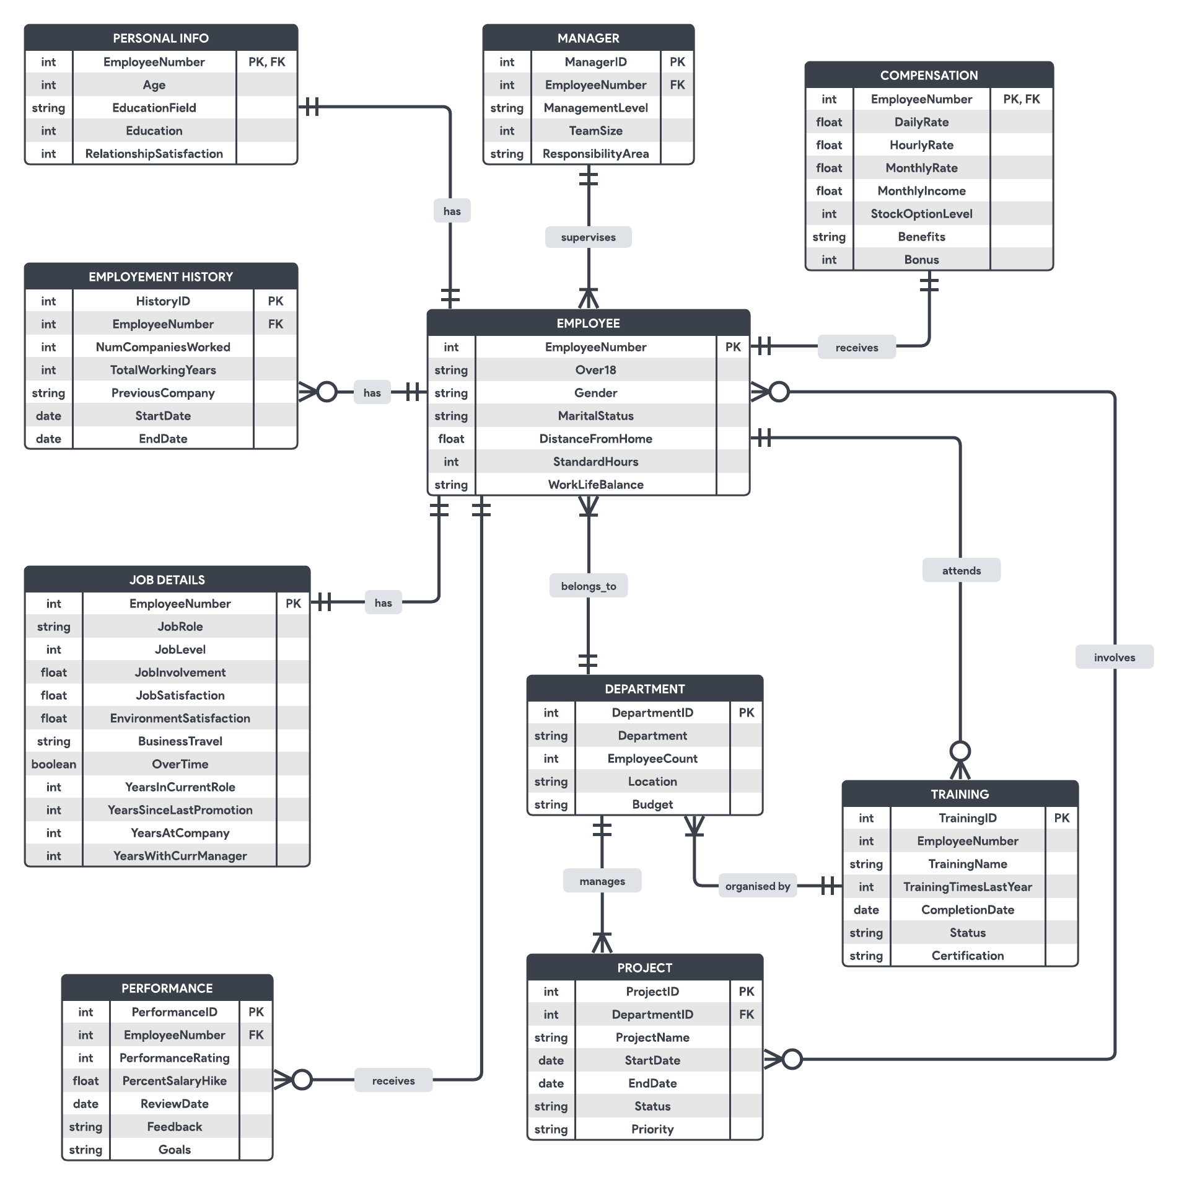

**SQL Queries for Table Creation**

**EMPLOYEE Table**

**CREATE TABLE EMPLOYEE (**

**EmployeeNumber INT PRIMARY KEY,**

**Over18 CHAR(1),**

**Gender VARCHAR(10),**

**MaritalStatus VARCHAR(50),**

**DistanceFromHome FLOAT,**

**StandardHours INT,**

**WorkLifeBalance VARCHAR(50)**

**);**

**PERSONAL_INFO Table**

**CREATE TABLE PERSONAL_INFO (**

**EmployeeNumber INT PRIMARY KEY,**

**Age INT,**

**EducationField VARCHAR(100),**

**Education INT,**

**RelationshipSatisfaction INT,**

**FOREIGN KEY (EmployeeNumber) REFERENCES EMPLOYEE(EmployeeNumber)**

**);**

**EMPLOYMENT_HISTORY Table**

**CREATE TABLE EMPLOYMENT_HISTORY (**

**HistoryID INT PRIMARY KEY,**

**EmployeeNumber INT,**

**NumCompaniesWorked INT,**

**TotalWorkingYears INT,**

**PreviousCompany VARCHAR(100),**

**StartDate DATE,**

**EndDate DATE,**

**FOREIGN KEY (EmployeeNumber) REFERENCES EMPLOYEE(EmployeeNumber)**

**);**

**JOB_DETAILS Table**

**CREATE TABLE JOB_DETAILS (**

**EmployeeNumber INT PRIMARY KEY,**

**JobRole VARCHAR(100),**

**JobLevel INT,**

**JobInvolvement FLOAT,**

**JobSatisfaction FLOAT,**

**EnvironmentSatisfaction FLOAT,**

**BusinessTravel VARCHAR(50),**

**OverTime BOOLEAN,**

**YearsInCurrentRole INT,**

**YearsSinceLastPromotion INT,**

**YearsAtCompany INT,**

**YearsWithCurrManager INT,**

**FOREIGN KEY (EmployeeNumber) REFERENCES EMPLOYEE(EmployeeNumber)**

**);**

**PERFORMANCE Table**

**CREATE TABLE PERFORMANCE (**

**PerformanceID INT PRIMARY KEY,**

**EmployeeNumber INT,**

**PerformanceRating FLOAT,**

**ReviewDate DATE,**

**Feedback TEXT,**

**Goals TEXT,**

**FOREIGN KEY (EmployeeNumber) REFERENCES EMPLOYEE(EmployeeNumber)**

**);**

**COMPENSATION Table**

**CREATE TABLE COMPENSATION (**

**EmployeeNumber INT PRIMARY KEY,**

**DailyRate FLOAT,**

**HourlyRate FLOAT,**

**MonthlyRate FLOAT,**

**MonthlyIncome FLOAT,**

**StockOptionLevel INT,**

**Benefits TEXT,**

**Bonus INT,**

**FOREIGN KEY (EmployeeNumber) REFERENCES EMPLOYEE(EmployeeNumber)**

**);**

**MANAGER Table**

**CREATE TABLE MANAGER (**

**ManagerID INT PRIMARY KEY,**

**EmployeeNumber INT,**

**ManagementLevel VARCHAR(50),**

**TeamSize INT,**

**ResponsibilityArea VARCHAR(100),**

**FOREIGN KEY (EmployeeNumber) REFERENCES EMPLOYEE(EmployeeNumber)**

**);**

**DEPARTMENT Table**

**CREATE TABLE DEPARTMENT (**

**DepartmentID INT PRIMARY KEY,**

**EmployeeNumber INT,**

**Department VARCHAR(100),**

**EmployeeCount INT,**

**Location VARCHAR(100),**

**Budget VARCHAR(100),**

**FOREIGN KEY (EmployeeNumber) REFERENCES EMPLOYEE(EmployeeNumber)**

**);**

**PROJECT Table**

**CREATE TABLE PROJECT (**

**ProjectID INT PRIMARY KEY,**

**DepartmentID INT,**

**EmployeeNumber INT,**

**ProjectName VARCHAR(100),**

**StartDate DATE,**

**EndDate DATE,**

**Status VARCHAR(50),**

**Priority VARCHAR(50),**

**FOREIGN KEY (DepartmentID) REFERENCES DEPARTMENT(DepartmentID),**

**FOREIGN KEY (EmployeeNumber) REFERENCES EMPLOYEE(EmployeeNumber)**

**);**

**TRAINING Table**

**CREATE TABLE TRAINING (**

**TrainingID INT PRIMARY KEY,**

**EmployeeNumber INT,**

**TrainingName VARCHAR(100),**

**TrainingTimesLastYear INT,**

**CompletionDate DATE,**

**Status VARCHAR(50),**

**Certification VARCHAR(100),**

**FOREIGN KEY (EmployeeNumber) REFERENCES EMPLOYEE(EmployeeNumber));**

**Creating a Data Lake**

A **data lake** is a centralized repository designed to store, process, and analyze large volumes of structured, semi-structured, and unstructured data. This approach provides flexibility in handling diverse data formats and supports advanced analytics, machine learning, and reporting. Below is a step-by-step guide to creating a data lake in Azure for managing and analyzing employee-related data.

**Steps Executed**

**1. Setting Up the Synapse Workspace**

* **Access the Azure Portal**:
  + Navigate to Azure Synapse Analytics and create a new workspace named shivamdheer.
  + Configure the workspace:
    - **Resource Group**: HR_Analytics_Project
    - **Region**: East US
    - **Primary Data Lake Storage Gen2 Account**: shivamdheer with the file system structured-data.
* **Grant Access Permissions**:
  + Assign the **Storage Blob Data Contributor** role to the Synapse workspace for access to Data Lake Storage Gen2.

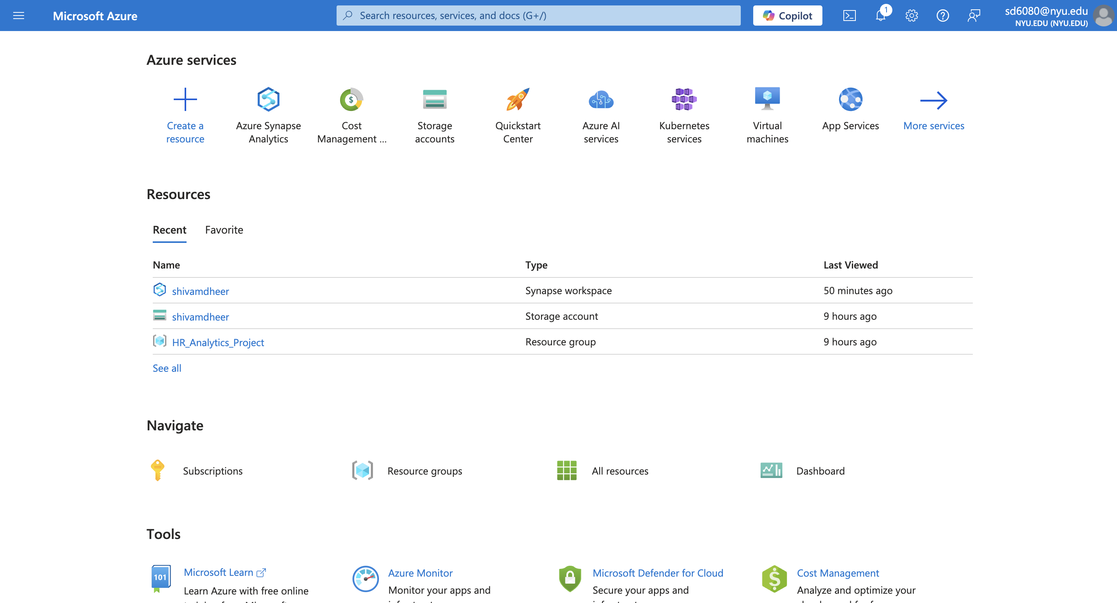

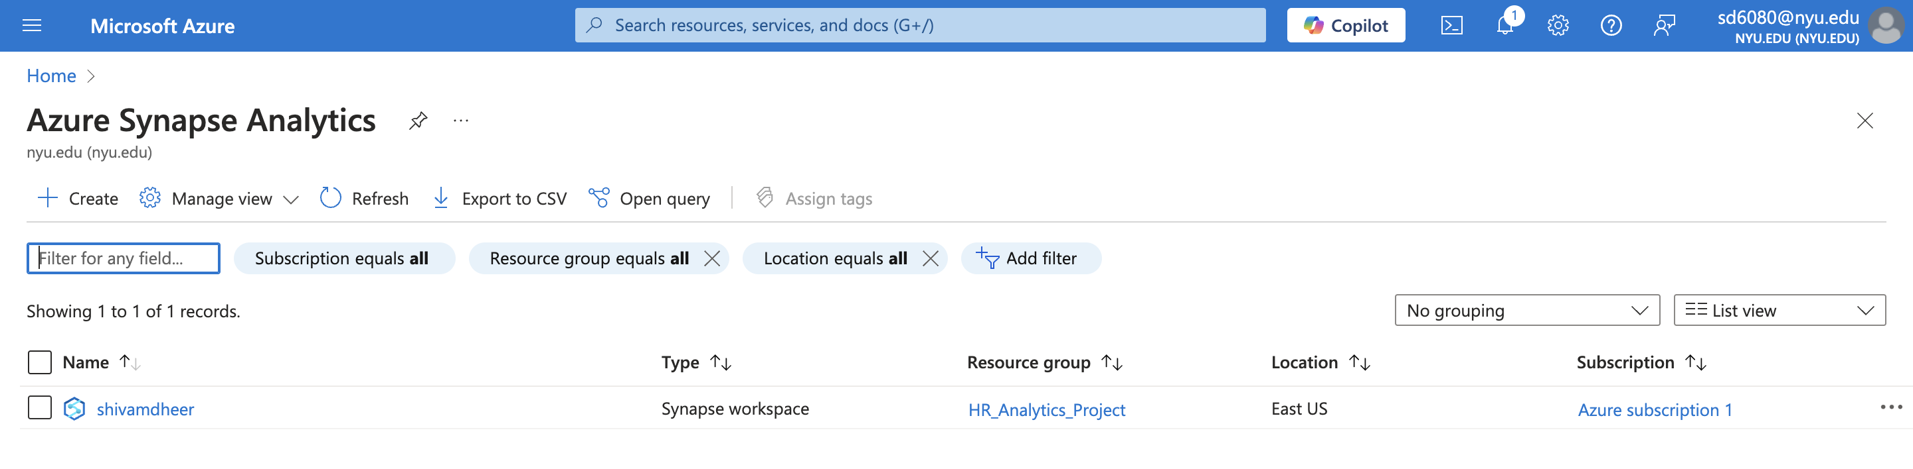

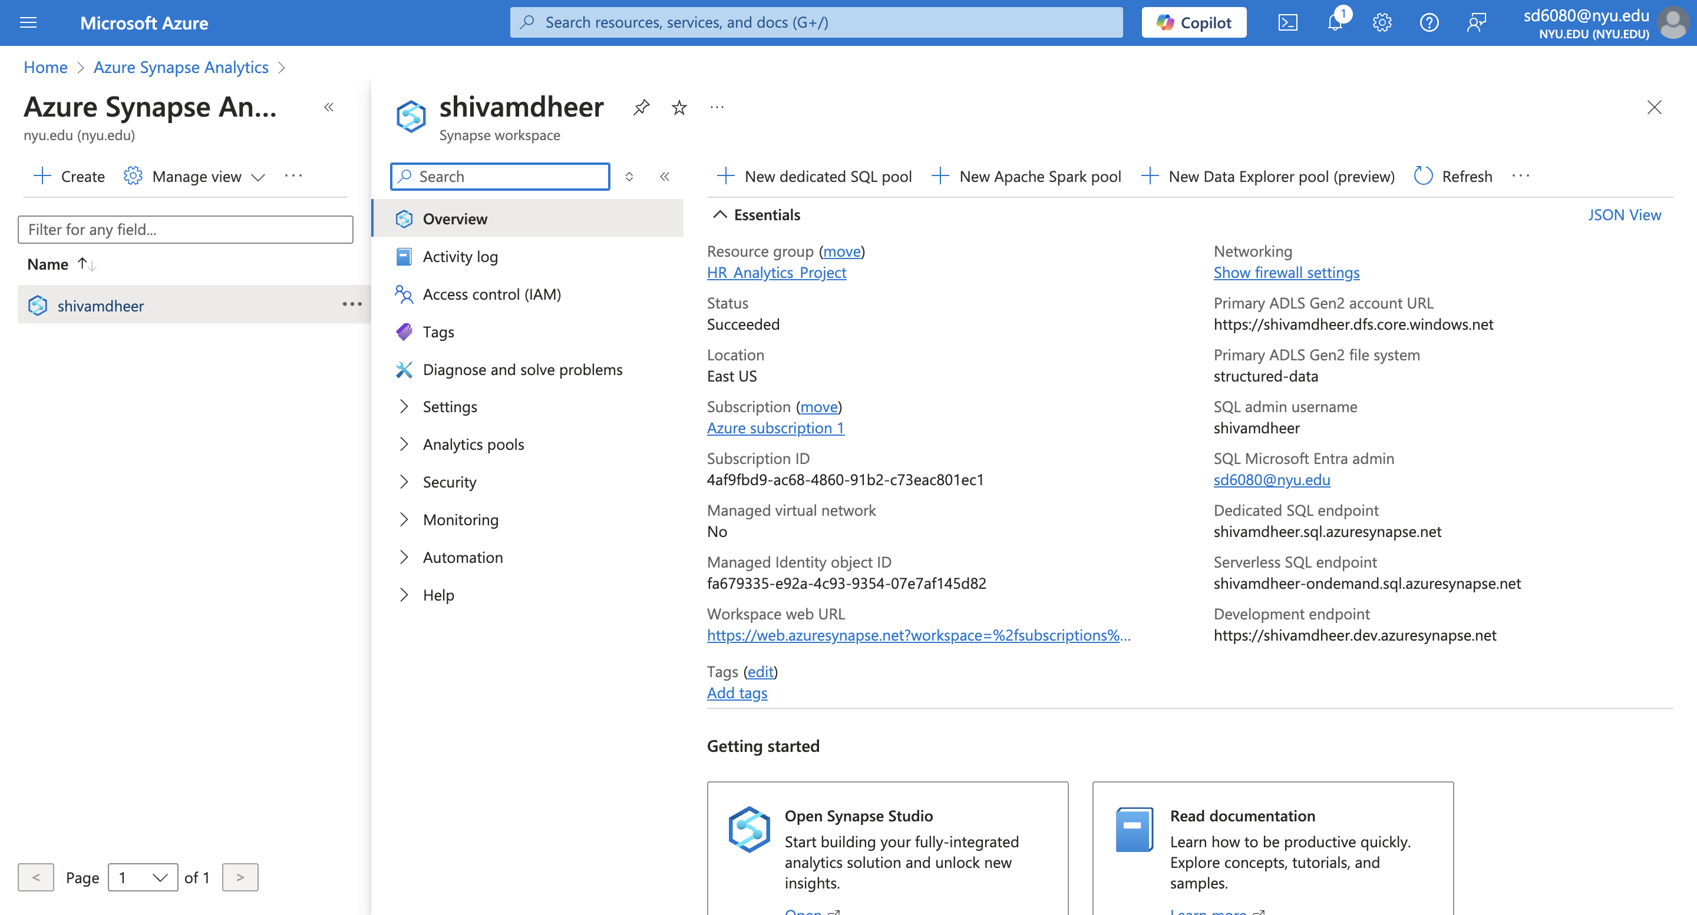

**2. Configuring Linked Services**

* **Open Synapse Studio**:
  + Use the workspace URL to log in to Synapse Studio.
* **Add a Linked Service**:
  + Navigate to **Manage > Linked Services**.
  + Create a linked service for Azure Data Lake Storage Gen2:
    - **Name**: DataLakeService.
    - **Authentication**: Azure Managed Identity or Account Key.
    - **Storage Account**: shivamdheer.

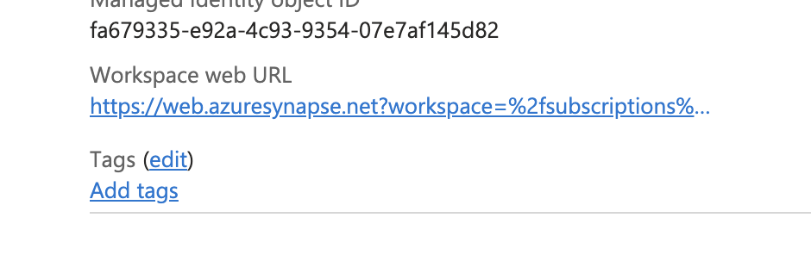

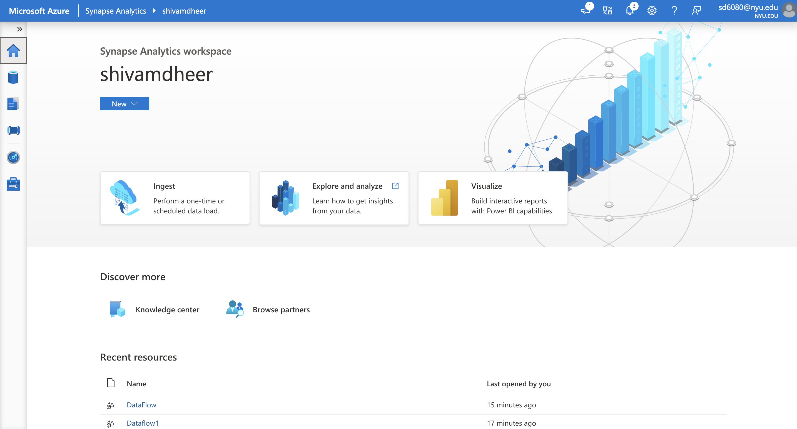

**3. Creating Datasets**

* **Structured Dataset**:
  + Navigate to **Data > Integration Datasets**.
  + Create a dataset for HR_Employee-Analytics.csv in the structured-data container.
  + Select **DelimitedText (CSV)** as the format and validate the schema.
* **Unstructured Datasets**:
  + Create datasets for:
    - Unstructured_Communication_Logs.csv.
    - Unstructured_Employee_Feedback.csv.
  + Use the unstructured-data container for these files.

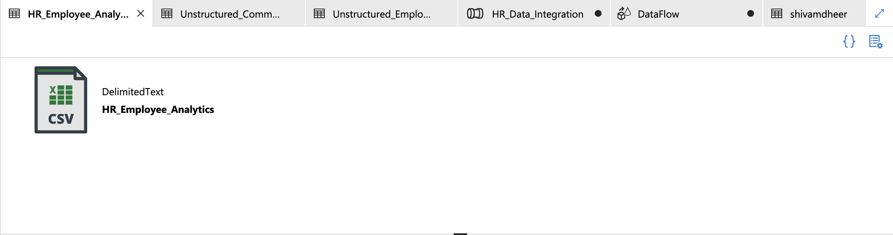

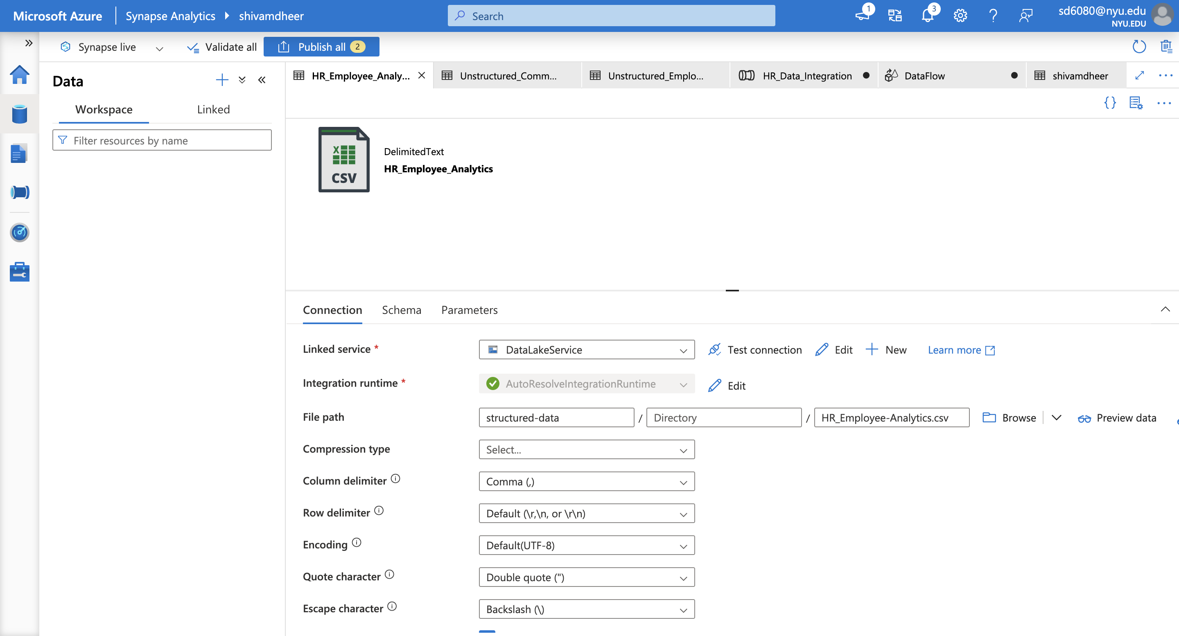

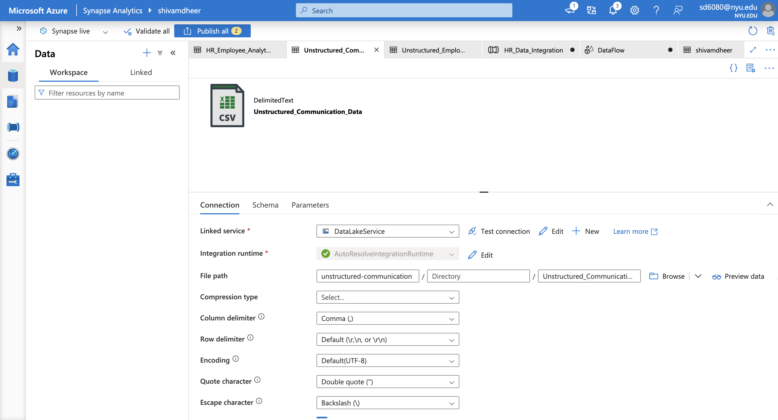

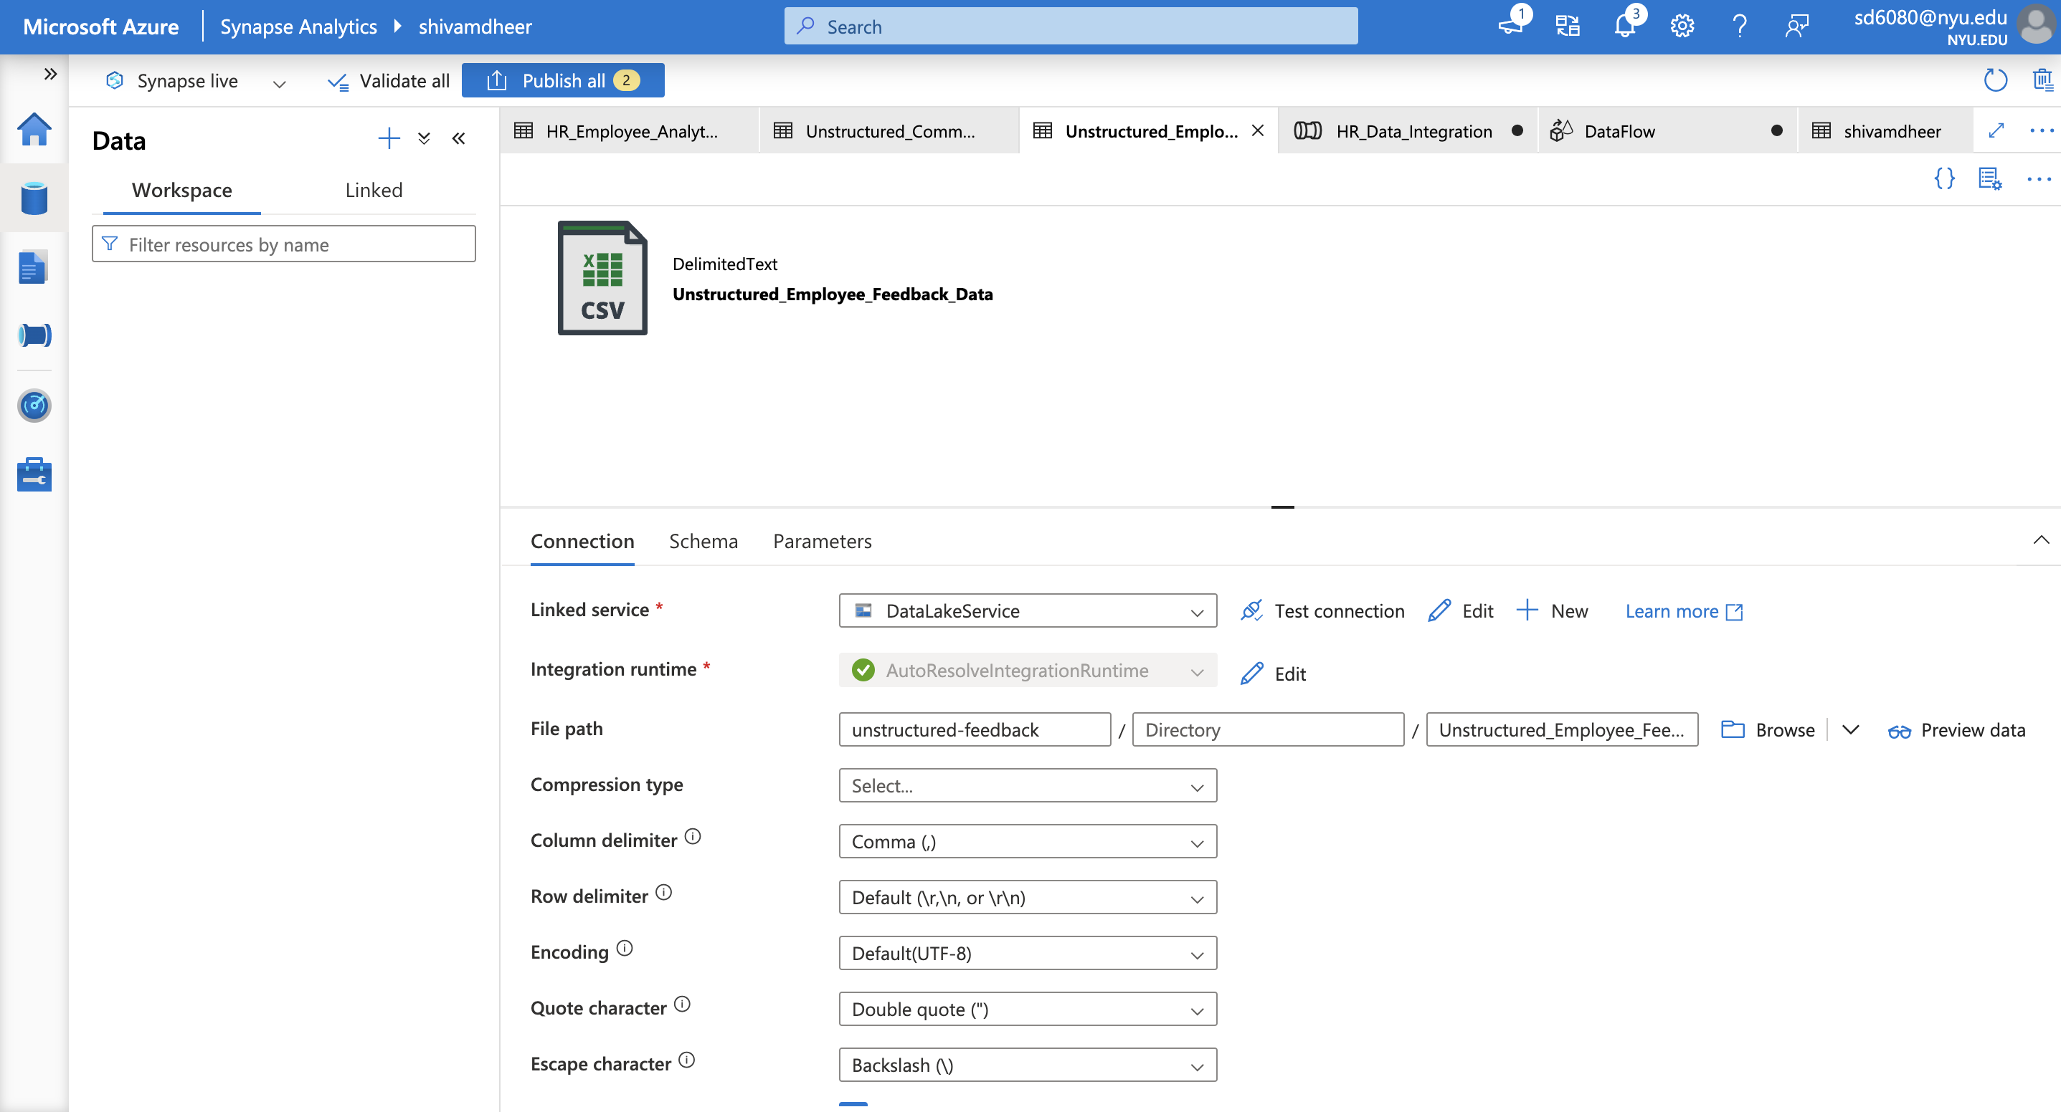

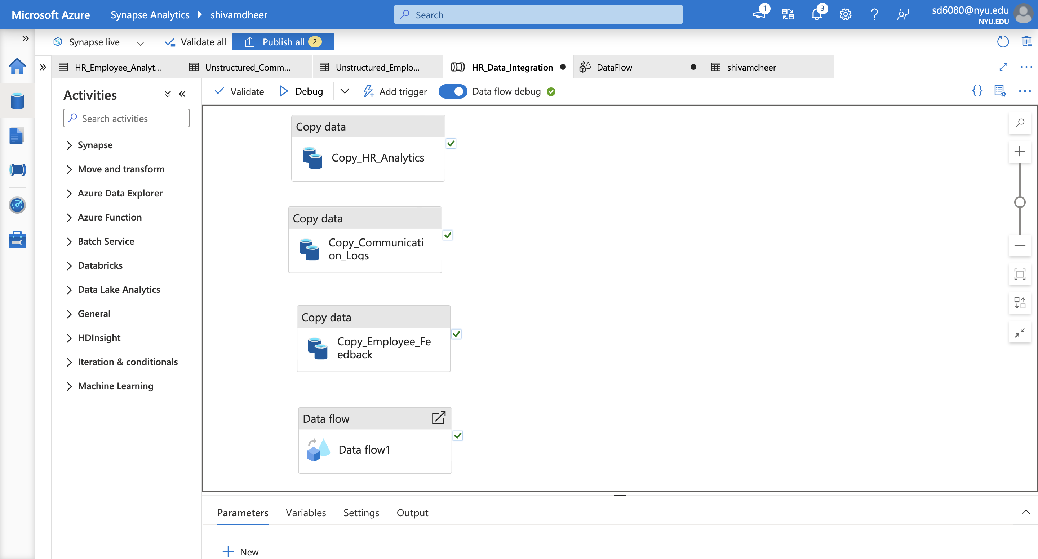

**4. Building the Pipeline**

* **Create a New Pipeline**:
  + Navigate to **Integrate > Pipelines**.
  + Create a pipeline named HR_Data_Integration.
* **Add Copy Data Activities**:
  + Add three **Copy Data** activities:
    - Copy_HR_Analytics for HR_Employee-Analytics.csv.
    - Copy_Communication_Logs for Unstructured_Communication_Logs.csv.
    - Copy_Employee_Feedback for Unstructured_Employee_Feedback.csv.
* **Configure Source and Sink**:
  + Set the source datasets to the respective files.
  + Configure the sink to output intermediate data to the processed-data/structured folder.

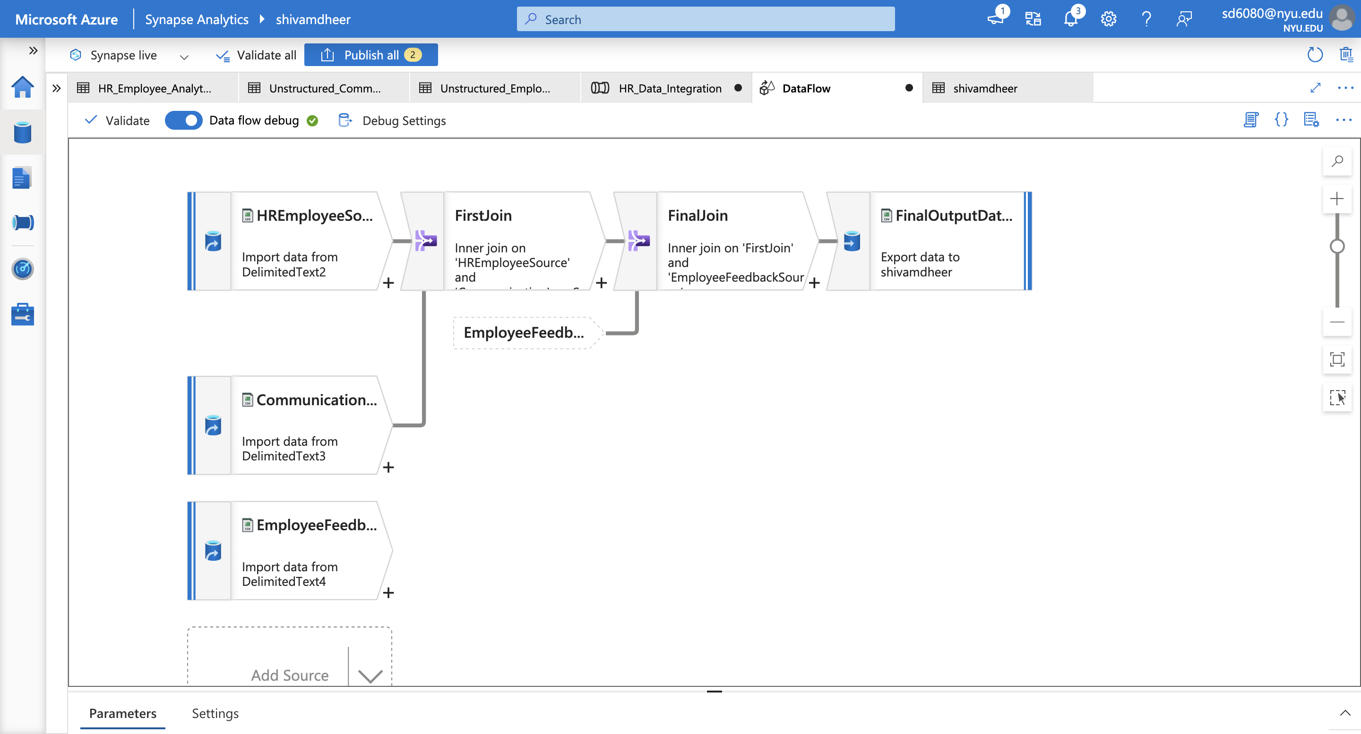

**5. Configuring the Data Flow**

* **Add a Data Flow**:
  + Drag a **Data Flow** activity onto the pipeline and create a new Data Flow.
* **Add Source Transformations**:
  + Add three sources for:
    - HR_Employee-Analytics.csv (structured data).
    - Unstructured_Communication_Logs.csv.
    - Unstructured_Employee_Feedback.csv.
* **Add Join Transformations**:
  + Use a **Join** transformation to combine HR_Employee-Analytics.csv with Unstructured_Communication_Logs.csv on EmployeeID.
  + Add another **Join** transformation to combine the result with Unstructured_Employee_Feedback.csv.
* **Add Derived Column (Optional)**:
  + Use a **Derived Column** transformation to clean or enrich the data (e.g., create a Full Name column by combining First Name and Last Name).
* **Add Sink Transformation**:
  + Configure the Sink to output the final combined data to the processed-data/combined folder in Azure Data Lake Storage Gen2.

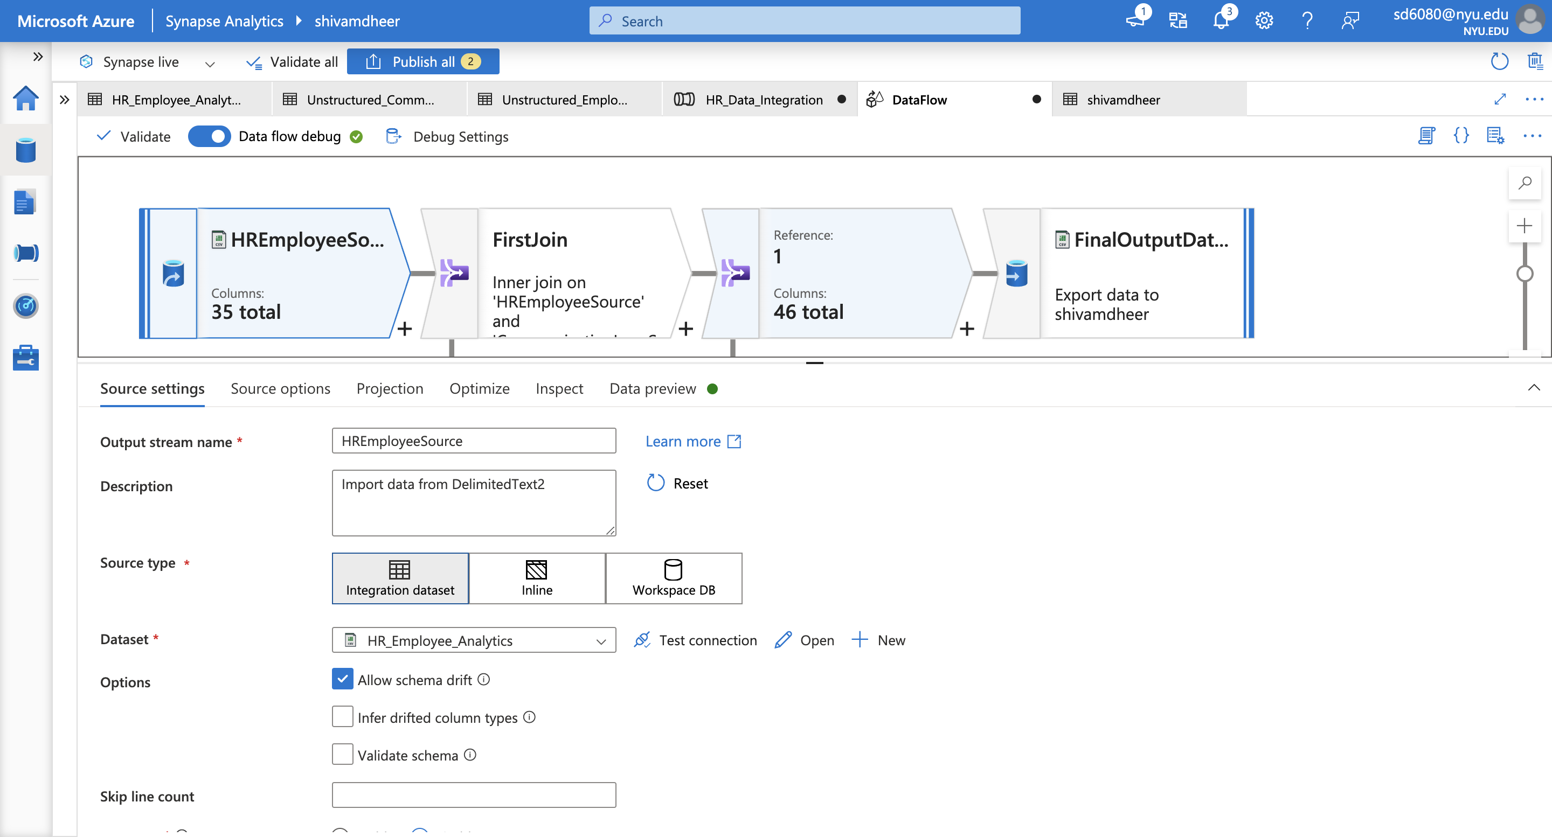

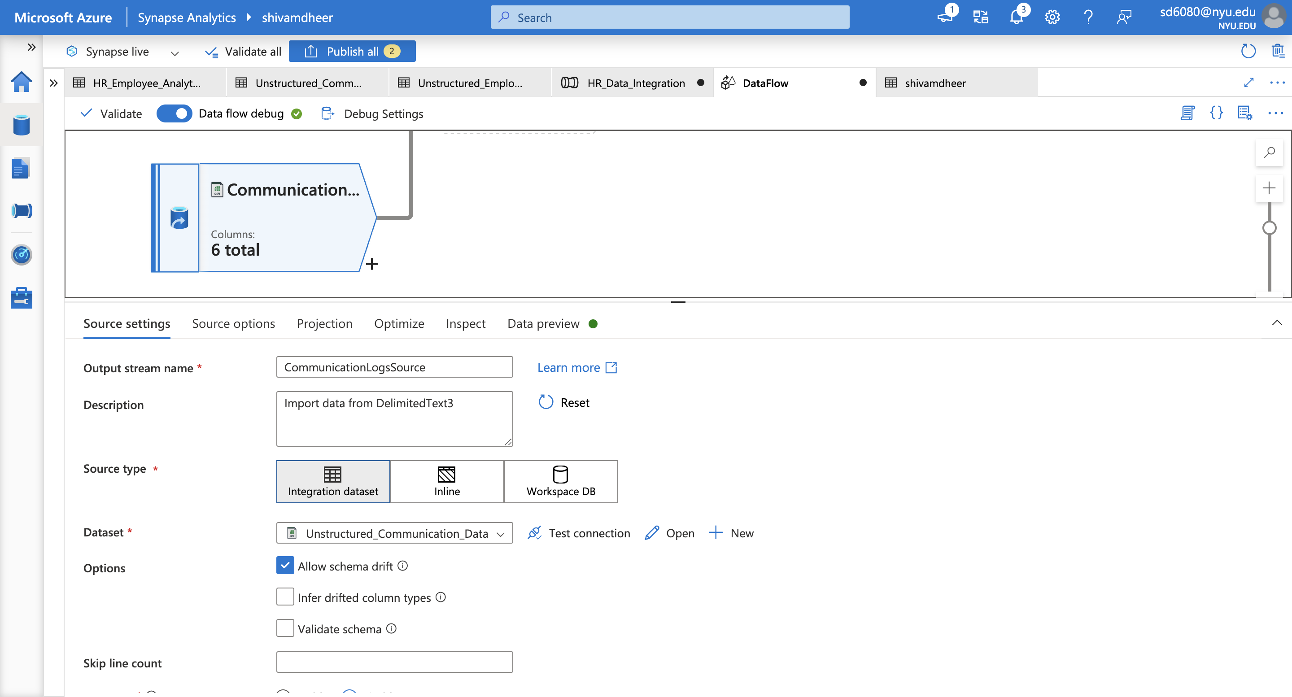

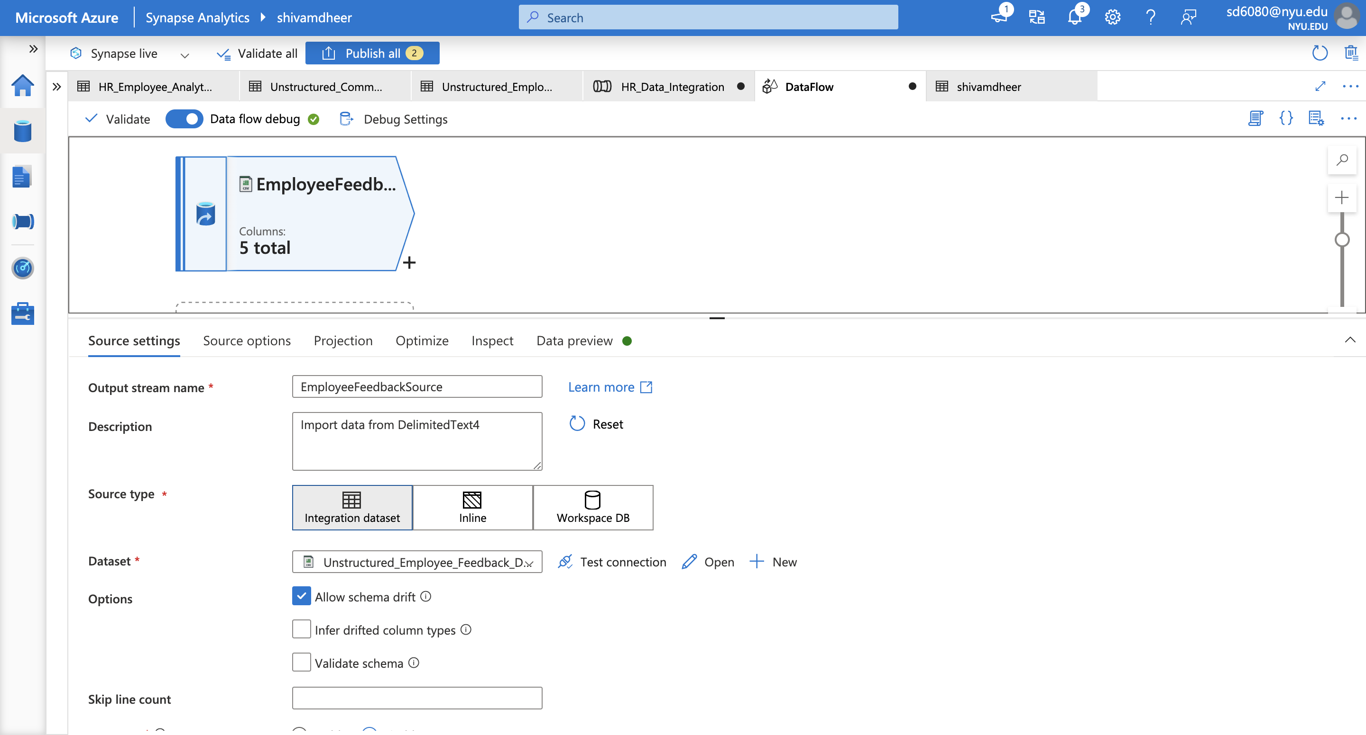

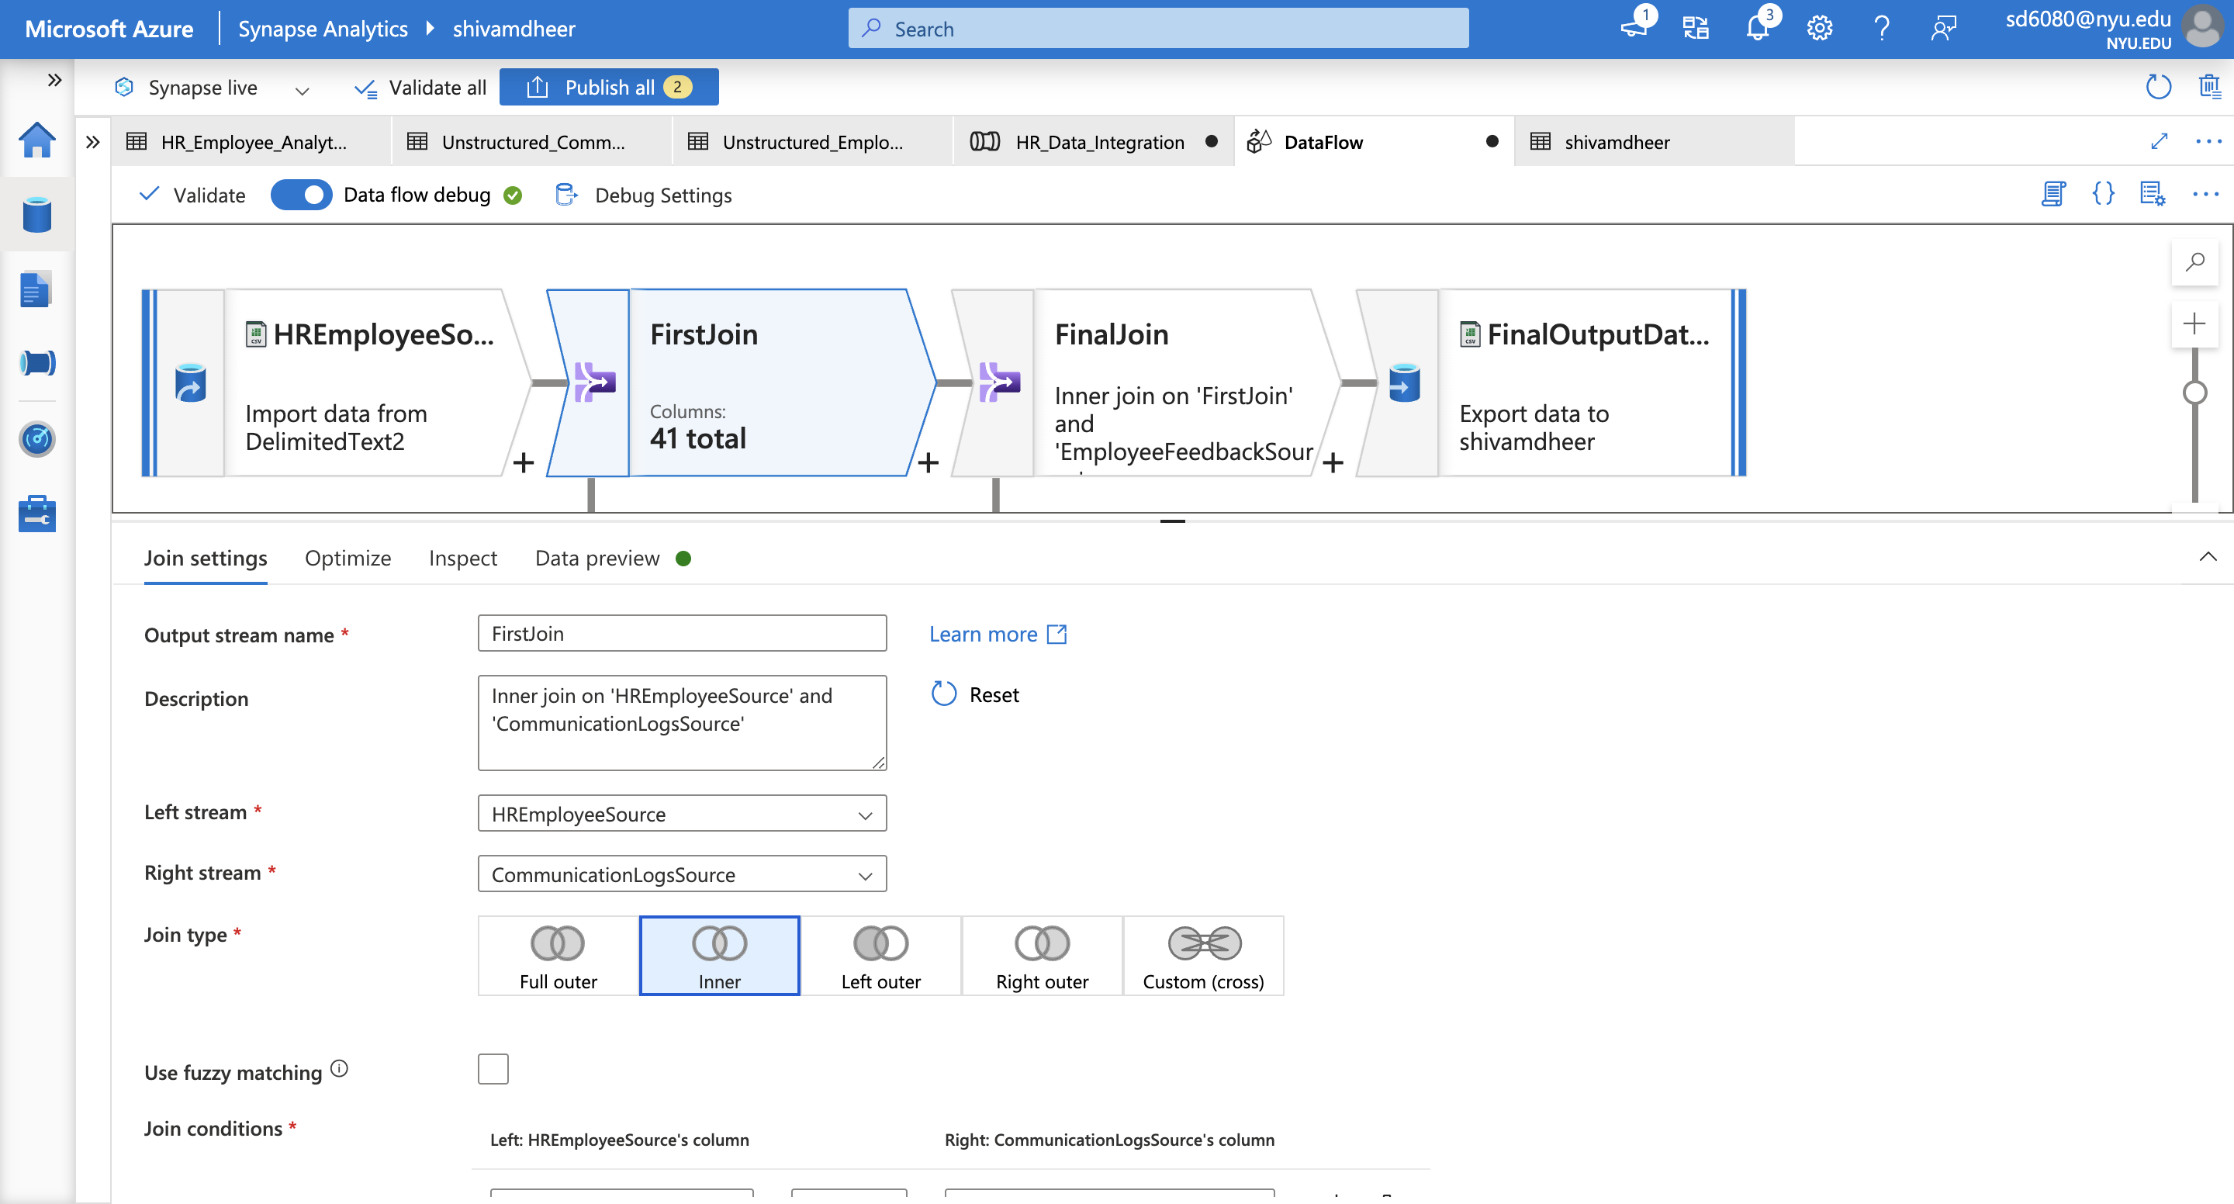

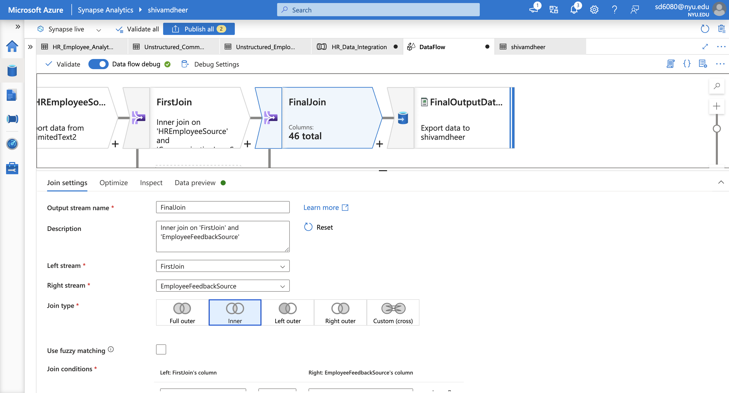

**6. Debugging and Validation**

* **Debug the Pipeline**:
  + Enable **Debug Mode** for the Data Flow and use the **Data Preview** tab to validate the output at each step.
* **Validate the Pipeline**:
  + Use the **Validate All** option in the pipeline editor to check for configuration errors.
* **Publish the Pipeline**:
  + After successful debugging, click **Publish All** to deploy the pipeline.

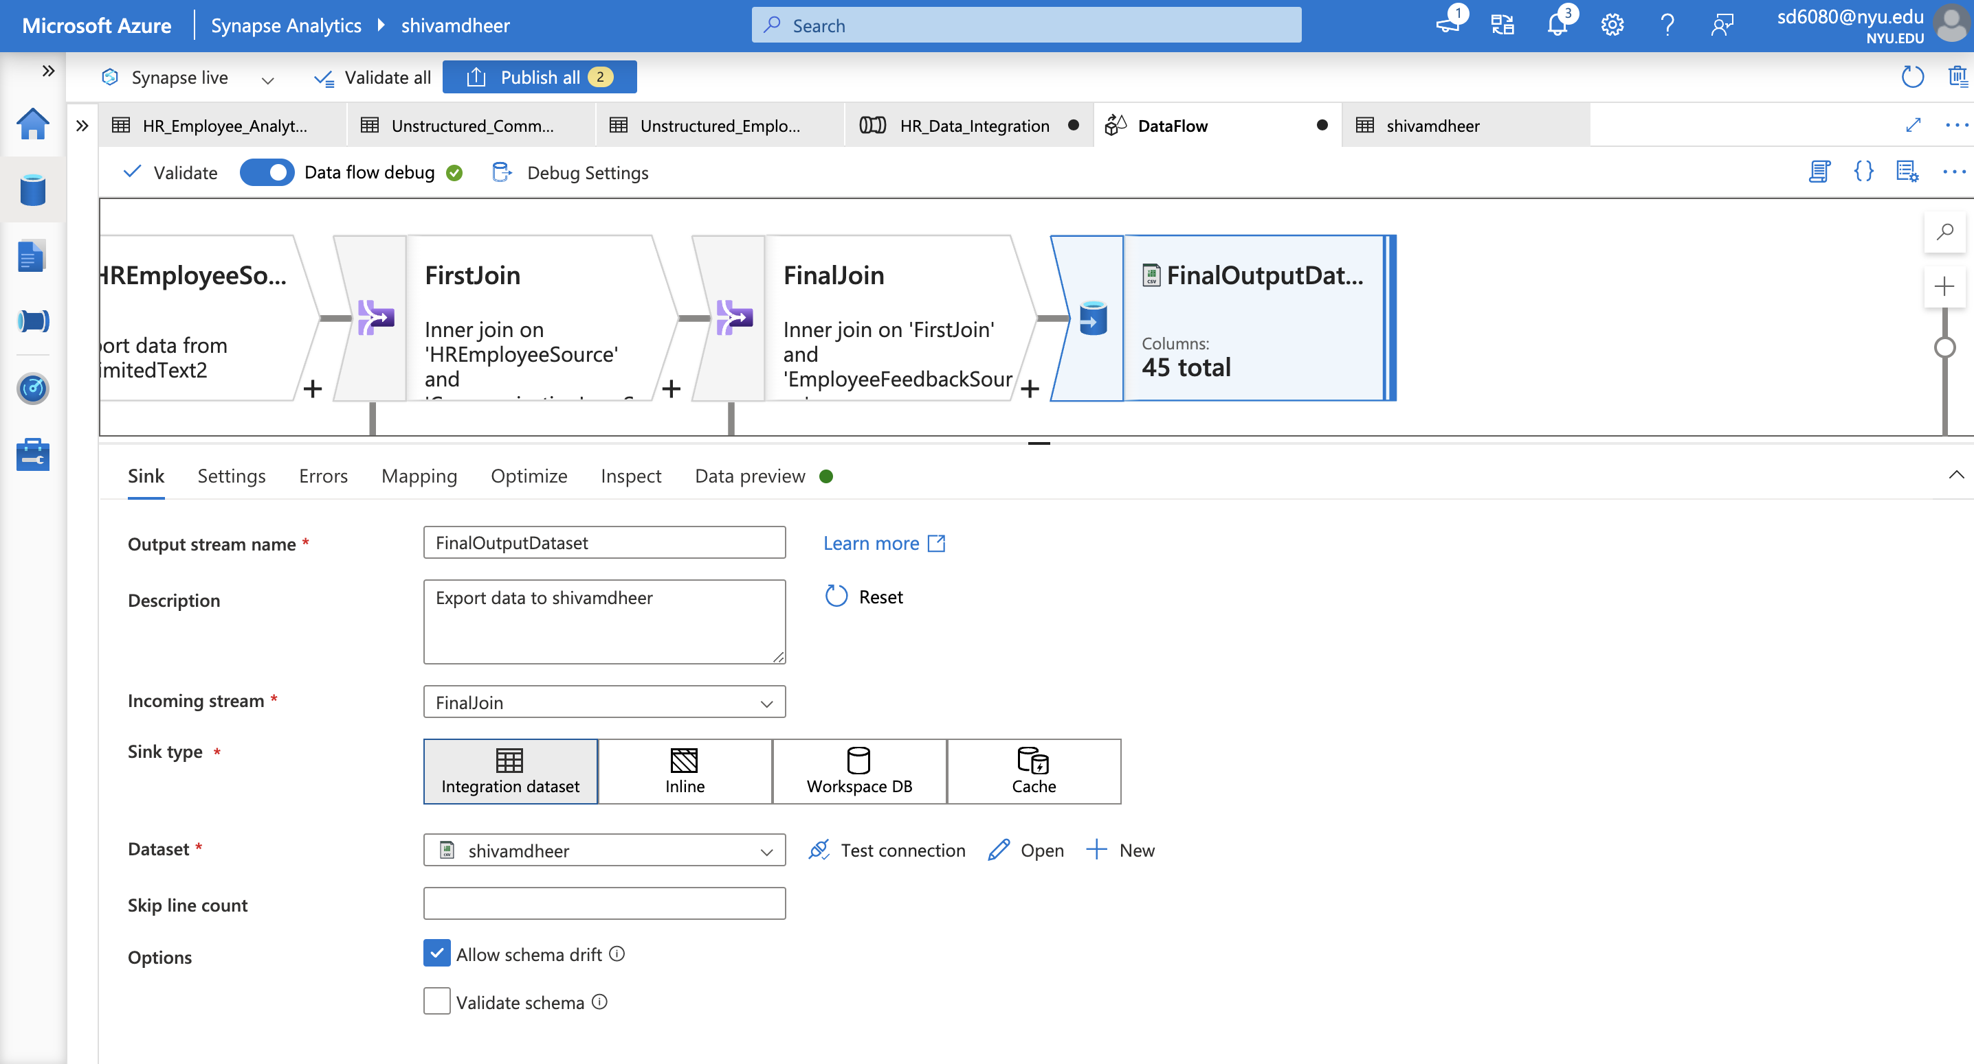

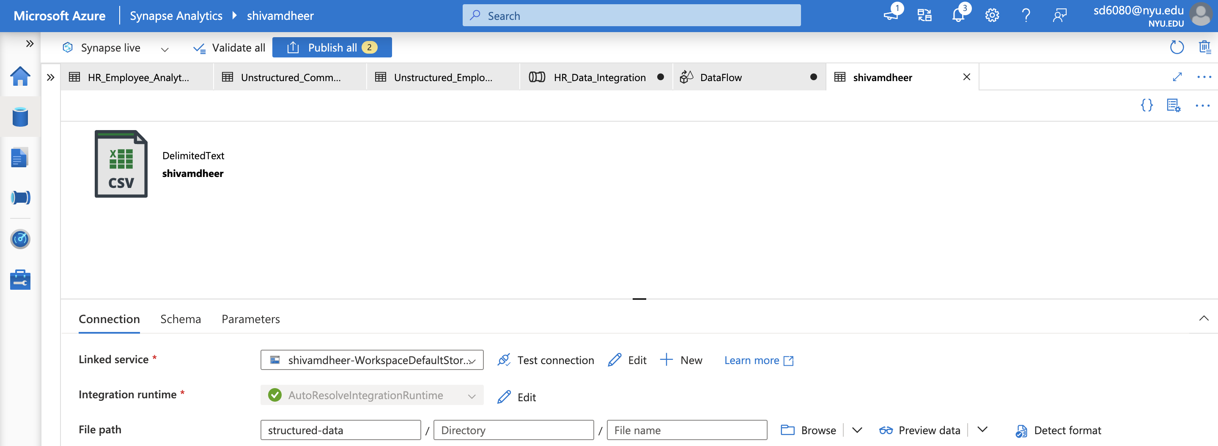

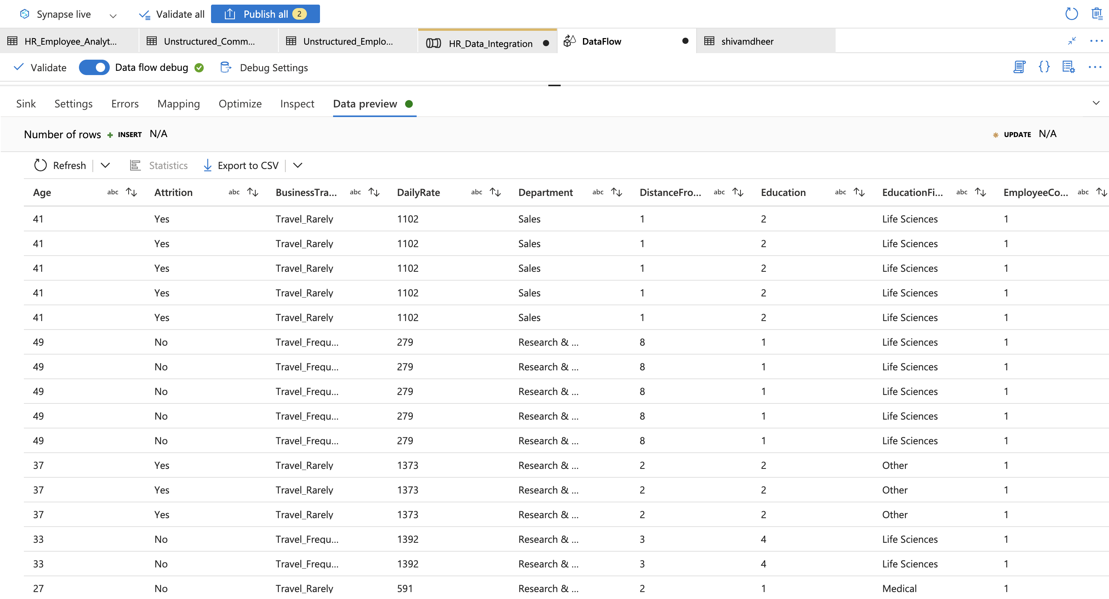

**7. Automation and Monitoring**

* **Add a Trigger**:
  + Add a trigger to automate the pipeline execution:
    - **Schedule-based**: Run at regular intervals.
    - **Event-based**: Trigger on file upload events.
* **Monitor Pipeline Runs**:
  + Navigate to the **Monitor** tab and track pipeline executions.
  + Review logs for any errors or issues.

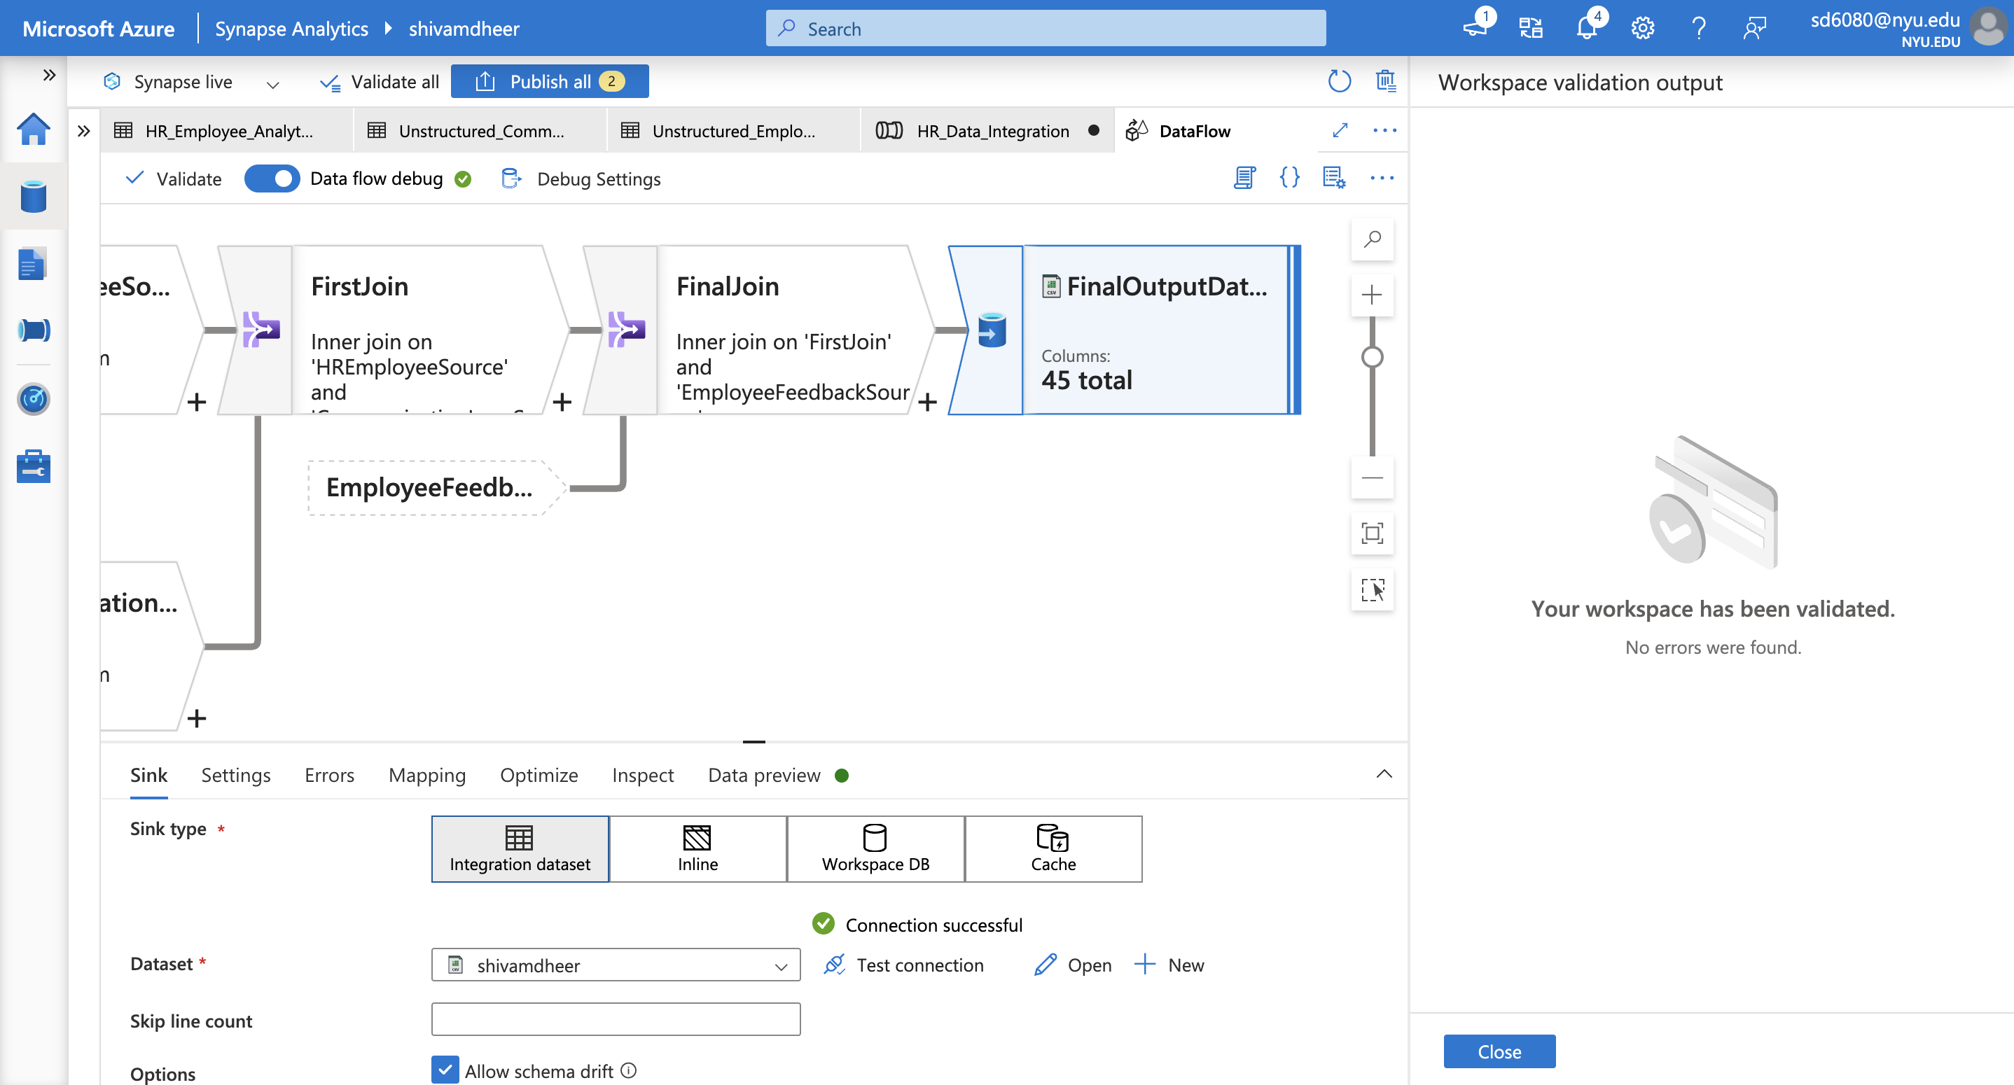

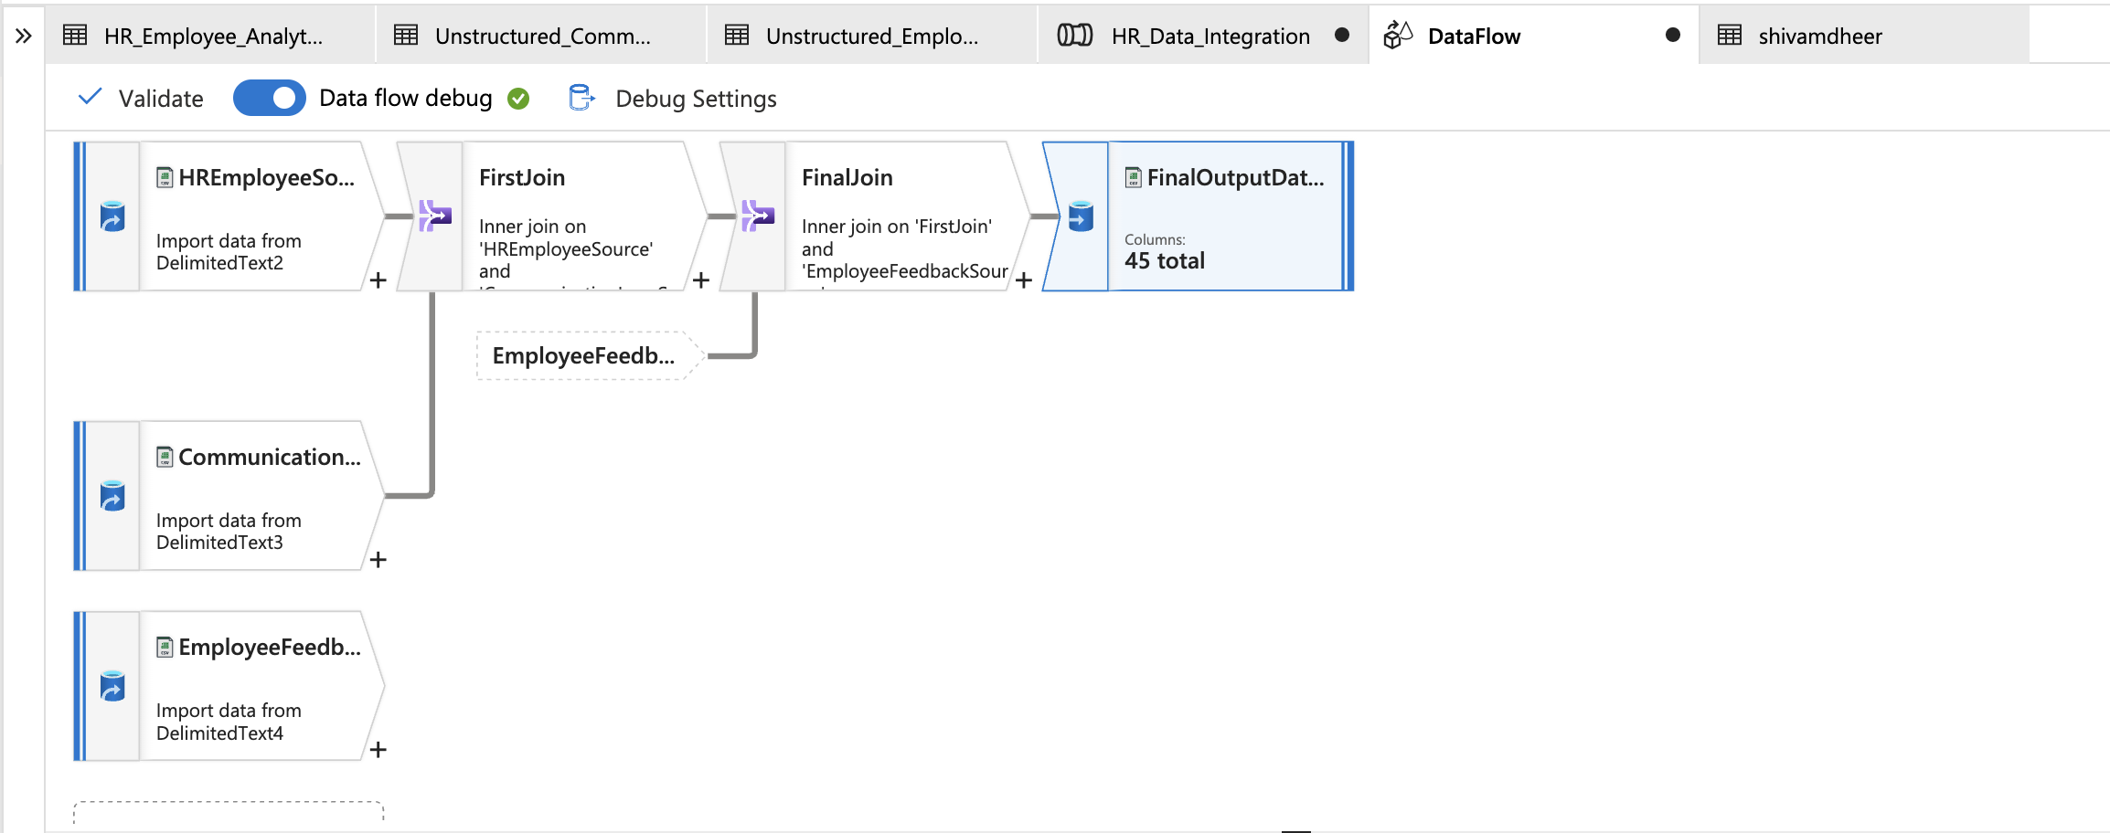

This project demonstrates the use of Azure Synapse Analytics for data integration, enabling structured and unstructured data to be processed and combined efficiently. The resulting pipeline automates the ETL process and outputs enriched data to Azure Data Lake Storage Gen2 for further analysis.